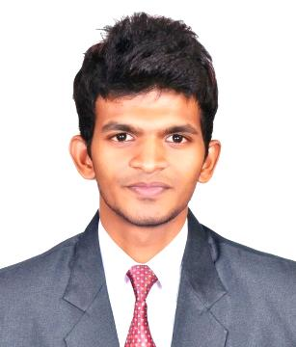
RUDRESH
rudresh.345071@2freemail.com
C/o- +971 501685421

Personality Traits:
- Interpersonal and relationship skills proven through my social activities
- Ability to communicate effectively with the team members
- Capable to work in team or individually and take up responsibilities
- Handle situation in smart way
Skill Set:
- MATLAB R2010a
- ANSYS Maxwell(Finite Element Analysis)
- Programming Language:C&C++(Basics)
- HTML(Basics)
Academic Qualification:
BachelorofTechnology | SMVEC, under Pondicherry University, India | 6.63 CGPA
HSC | Greenpark Matriculation HSS, India | 80.8%
SSLC | Venus Matriculation HSS, India | 82%
Area of Interest:
- Non-Renewable Energy(Thermal)
- Transformer
- Designing
Achievements:
Presented my research work in CAPACIT 2014, International Conference held at NewDelhi, conducted by IEEMA (Indian Electrical and Electronics Manufacturers Association)held on November 20th& 21st, 2014
Academic Projects:
Title: Semi-Automated boarding system for physically challenged people in railway coach

Description: Our project provides an optimum solution for accidents occurring due to platform gap. According to this project, when the train reaches the platform its arrival is sensed automatically by the RFID reader attached to the train.
Mini Projects:
Title: Ultra-Sonic Obstacle Detection Robot
Description: The main objective of this project is to find the obstacles in its path and avoiding by the application of Ultra-Sonic sensor

Co-curricular Activities:

27 Nov–2 Dec, 2014 | In-Plant training at 230 KV Auto Sub-Station  @Poothamedu, Villupuram, India
14 Feb, 2015 | Participant in Robo Race & Line Follower Robot  @Velammal Engineering College, Chennai
27 Sep – 2014 | Participant in International Workshop in Emerging Technologies of Robotics @ Dr.Paul’s Engineering College, Puducherry
13 Sep, 2014 | Participant in Wall-E Robot @ SRM University, Chennai
6, 7 Sep, 2014 | Participant in Computational Analysis Of Electrical Machines workshop @ VIT, Chennai
15, 16 Mar, 2014 | Participantin Robo Terrain, Robo Rally Anna University  @ Madras Institute of Technology, Chennai

Personal Details:
Date of Birth : August 30, 1995
Lingoes Known : English, Hindi & Tamil
Career Objective:
Seeking a learning, Challenging & progressive career which could provide me with sufficient opportunities to apply my academic knowledge for achieving organizational goal & as well as my personal enrichment.

