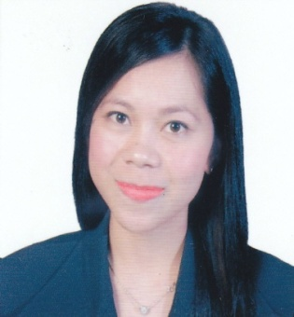
Jovielyn
C/o-Contact number: +971 504973598
Email address: jovielyn.345142@2freemail.com

PROFFESIONAL SUMMARY .
Thorough Accounts Officerwith office administration and secretarial background who is able to maintain an active spreadsheet of many different types of active accounts. Very skilled at monitoring accounts payable activity, assisting in monitoring an aging report and developing comprehensive reports to assist management. Specializes in retail and manufacturing organizations and has excellent customer/supplier relations.Participate in the company goal by reaching target collections and meeting the deadlines.
SKILLS AND QUALIFICATIONS .
- Good organization skills.
- Good time management.
- Good communications skills, written and verbal.
- Discretion.
- Accuracy and good attention to detail.
- An ability to stay calm and tactful under pressure.
- Excellent customer service skills
- Team player
- Quality service
- Self motivation.
- QuickBooks/Microsoft application

WORK EXPERIENCES .

Tax Compliance Accountant/Collection Assistant
Emerson Network Power Philippines
July 2015- February 2017

Responsibilities
- Prepares tax returns for various vendors.
- Updates receivables by totaling unpaid invoices
- Contacts customer on past due invoices via phone and email
- Prepares/updates reports as required by the Market Unit
- Negotiate Credit Extensions to customer when necessary
- Manages disputed invoices. Identifies issues, escalates to proper channels, and sets timeline in resolving the issue
- Protects organization's value by keeping information confidential.
- Accomplishes accounting and organization mission by completing related results as needed.
- Negotiate with payment schedule
- Communicate to the customer regarding the collection.

Bookkeeper/Office Administration
Yusay Credit and Finance Corporation-Philippines
April 2012-April 2015

Responsibilities
- Maintains general ledger by transferring subsidiary account summaries.
- Petty cash handling/Bank Reconciliation
- Balances general ledger by preparing a trial balance; reconciling entries.
- Maintains historical records by filing documents.
- Prepares financial reports by collecting, analyzing, and summarizing account information and trends.
- Preparation of Loans report.
- Complies with national and local legal requirements by studying requirements; enforcing adherence to requirements; filing reports; advising management on needed actions.
- Contributes to team effort by accomplishing related results as needed.
- Liaising with the bank for all credit related queries
- Bank Reconciliation of all bank accounts
- Preparing deposit slips for remittance in the bank
- Preparing customer statements by verifying
- Reconciliation of accounts receivable
- Communicating the receipts of wire transfers
- Liaising with collection/leasing department for rising manual invoices
- Cheque return update in the system
- Liaising with audit requirements
- Resolving queries
- Acknowledging online receipts

Secretary/Office Administration
Samillano and Associates, CPA’s
April 2011-April 2012

Responsibilities

- Answering telephone calls
- Arranging appointments
- Taking messages
- Managing database
- Liaising with relevant organisations
- In Charge with office supplies/documents

EDUCATION .
Bachelor of Science in Commerce major in Management Accounting, 2011
University of Negros Occidental Recoletos, Philippines

PERSONAL DATA .
Date of Birth: 29 October 1988 Civil Status: Single
Age: 28 years old Height: 5’1
Birthplace: Bacolod City Weight: 50 kg
Citizenship: Filipino Languages Spoken: English & Filipino
Religion: Roman Catholic

