CURRICULUM VITAE

SANTHOSH 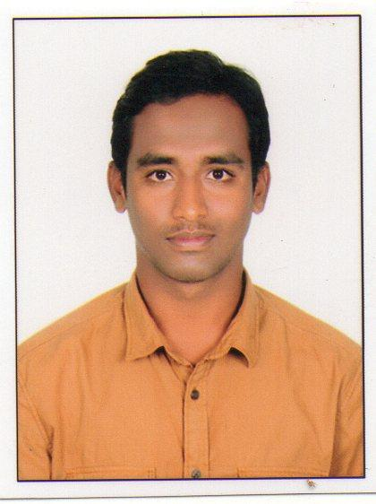
Bachelor of technology (b.tech).
Department of Mechanical engineering.
Kakatiya University, Warangal, India. Email : santhosh.345175@2freemail.com

CAREER OBJECTIVE
_____________________________________________________________________________________
To be a part of an organization where I can fully utilize my skills and make a significant contribution to the success of the employer and at the same time my individual growth.

EDUCATION QUALIFICATIONS
_____________________________________________________________________________________Bachelor of Technology in Mechanical Engineering May 2016
Warangal institute of technology and sciences.
Kakatiya university , Warangal ,Telangana, India.
Percentage : 60 %.
Intermediate education Certificate May 2012
S.R Jr College, Board of Intermediate education.
Karimnagar, Telangana, India.
Percentage : 79.6%.
Secondary School Certificate (S.S.C) March 2010
Goutham high school, Board of Secondary Education.
Korutla,Telangana, India.
Percentage : 73%.
ACADEMIC PROJECTS
_____________________________________________________________________________________
Title : DESIGN,STRUCTURAL AND FATIGUE ANALYSIS OF A FOUR STROKE DIESEL ENGINE CONNECTING ROD
Location : Warangal, Telangana, India.
Duration : Sept 2014 – Jan 2015
Team size : 5
Responsibilities : Designing connecting rod in pro-e and analyzing structural and fatigue
analysis in ansys software.

SOFTWARE SKILLS
_____________________________________________________________________________________
● Designing Softwares : PRO-E , Catia V6, Auto CAD , Ansys, Hypermesh.
● Graphic Design : Microsoft Powerpoint
● Documentation : Microsoft word, Microsoft Excel.
● Operating Systems : MS Windows 95/98/2000/ XP/ VISTA/Windows7/windows8.1.

AWARDS AND ACHIEVEMENTS
_____________________________________________________________________________________
● Completed CAE course in CITD (central institute of tool designing) hyderabad,India.
● Completed PRO-E course in wind will technologies Pvt Ltd , India.
● Participation in technical fest in our college.
● Participation in blood donation camp held at our college.

EXTRA CURRICULAR ACTIVITIES
_____________________________________________________________________________________
● Good communication skills.
● Reading Books.
● Good knowledge on Computer.
● Watching documentaries.
● Playing cricket.
PERSONAL PROFILE
_____________________________________________________________________________________
Date of Birth : 07-01-1995
Marital Status :Unmarried
Languages known : English,Telugu,Hindi.

DECLARATION
_____________________________________________________________________________________
I hereby declare that the information furnished above is true to the best of my knowledge.

(A.SANTHOSH)

