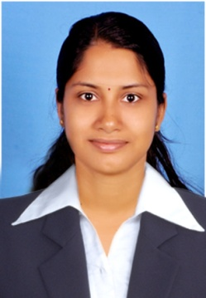
Sheena.

C/o-Mob:-+ 971 501685421
Email:- sheena.345279@2freemail.com

Objective
Seeking a challenging position where I contribute my skill, knowledge and experience to an institute which will help me in utilizing my strong dedication that will give me an opportunity to develop my career.

Personal skills

  - Quick learner, hard working, self thinking, sincere & helpful
  - Good presentation skills and interpersonal communication
- Easily adaptable to any environment

Academics

- M.Sc. Medical biochemistry, Kannur University, 2012- 70%
- B.Sc. Biochemistry, Bharathiyar University, 2008- 75%
- Plus Two Science, Higher Secondary Board of Tamil Nadu, 2005- 82%
- S.S.L.C, Board of public exam Tamil Nadu, 2003- 90%
- Diploma in Bioinformatics

System Exposure
Sound Knowledge in Internet technology & commonly used all Application Software’s etc...

Academic Projects

- M.Sc. project on the topic, “Evaluation of oxidative stress markers in Pregnancy Induced Hypertension” at PSG Institute of Medical Sciences and Research, Coimbatore.

- B.Sc. project on the topic “Genetic manipulation of tomato plant with Hevein Gene through agarobacterium mediated transformation & immune technology ”, at Shreedhar Bhats Laboratory, Bangalore.

Professional Experiences

- Worked at DM –WIMS (NABH accredited) from May 2016 - December 2016 as Biochemist.
- Worked at Doctors Medical Laboratory as Biochemist from November 2015- April 2016
- Worked at Dhanalakshmi Hospital (NABH accredited), Kannur from November 2014 – November 2015 as Biochemist cum Deputy Lab in charge
- Worked at National Hospital, Calicut, from September 2013- October 2014 as Biochemist cum Lab in charge
- Worked at DDRC SRL Diagnostic Services from July 2012 – Aug 2013 as Junior Biochemist

Personal Details

DOB 14/12/1987
Languages Known English, Malayalam and Tamil
Marital status Married

Declaration

I hereby declare that the above written particulars are true to the best of my knowledge and belief.

