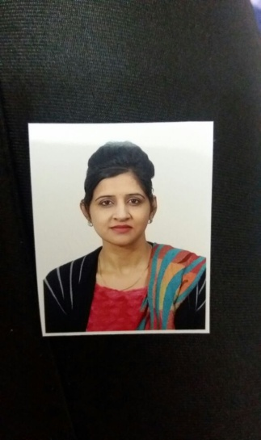
Talwinder
Associate|Admin| Coordinator|
C/o- +971505891826 talwinder.345299@2freemail.com
Education

B.Sc- Bachelorof Science(industrial chemistry) 2004
Pre University–12th|(first division)
HigherSecondary–10th|(first division)

Executive Summary

• 4 year experience as school coordinator, admin and purchasing goods with the knowledge of stationary , uniforms and others needed stuff.
• 1 years of business analysis and co-ordination experience with knowledge of Health, Motor and
Non Motor ,General business processes.
• Possess a detailed oriented nature with good communication, inter personal skills & recognized for
Being valued team player.
• Highly competitive, passionate, able to achieve results others believed to be impossible.
• Maintain targets for timely completion of tasks along with maintaining high standards for quality.
• Well adaptive towards corporate culture and behavior & ability to work under pressure.
• Develop contacts, effectively make your presence felt and be recognized in the job by performing efficiently.

Areas of Expertise

Computer Proficiency Professional Skills

• OperatingSystem|Windows7
• Packages |MS-Office, Excel/Word

• Typing|Junior English Type writing
• Understanding the Business requirements of the clients.
• Meeting the expectations and the dead line of the Process.
• Supporting team during high volumes with high production and Quality.
Experience

Ranvir Trading Co. Present
Technical & Sales Coordinator |Admin |Purchasing Assistant

Company founded in 2005 has grown as one of the leading companies engaged in Trading, Importing, Exporting, Consulting, Designing, Manufacturing,and Installing.

• Handling calls and maintain the records.
• Creation of Job cards, organizing and supervising Technicians.
• Coordinate between clients and technicians.
• Supervising the work of technicians, monitoring the work load & motivate, influence and guide to reach targets.
• Follow up with existing clients for Annual Maintenance Contract.
• Preparing quotation for maintenance and annual maintenance.
• Maintaining records, Filing documents, Typing Correspondence, Preparing schedules, checking records, sending fax and copies.
• Preparing weekly, monthly and yearly sales report.
• Monitoring technician’s absence and annual leave entitlements. .
• Attending enquiries via email and provide quotation.
• Preparing sales orders and coordinate with stores for delivery.
• Responding to complaints from customers and give after-sales support.
• Handle the processing of all orders with accuracy.
• Keep clients informed of unforeseen delays or problems.
• Set up and coordinate meetings and conferences.
• Having good working knowledge of Computer software packages & MS-Office (Word/Excel/Access)etc.
• Forecasting levels of demand for services and products to meet the business needs and keeping a constant check on stock levels.
• Identifying potential suppliers and building and mainaining good relationships with them
• Keeping contract files and using them as reference for the future.
• Negotiating price with the suppliers once the order is confirmed.
• Preparing purchase orders and coordinating with suppliers and stores regarding arrival of goods.
• Handling change order requests.

Saffron public school India June2007 to September 2011
Coordinator|Associate|

One of the leading asset management groups, serving many parents,students,helpers,technicians,bus drivers etc for betterment of students
• With excellent coordination and multi-tasking ability, promoted from in bound to live discussion
• Resolving parents query at given time.
• Active participation in resolving and managing issues in all related parts .
• by solving students issues including transportation,sports,study by giving them complete information time to time
• make co ordination between principal and teachers. Also with students n working helpers to resolve problems
• Maintaining time table,and checking fees records.
By organizing Annual function,sports and other cultural meets .
arranging different workshops for teachers to improve their efficiency

Achievements:

✓Recognizedas a best Performer of a team.
✓I have done anchoring in Annual Function.
✓Appreciations from our clients as well top management for account management and client handling.
✓Recognized for high level of success in carrying out event coordination.

PersonalDetails

Date ofBirth- 4th September 1980 Nationality -Indian
Marital Status- Married CountryofResidence-UAE
LanguagesKnown - English|Hindi|Punjabi|

-------------------------------------------------

