WAQAS

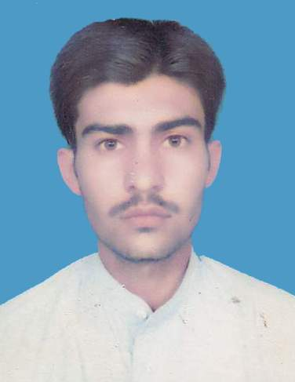
Marital Status: Single
C/o-Phone Number#: +971504973598
Email Address: waqas.345313@2freemail.com

ACADEMIC QUALIFICATIONS:

- Faculty Of Science Kohat Board
(F.Sc) (2008-2009)

( S.S.C) Kohat Board
(Science) (2006 -2007)

PROFESSIONAL SKILLS AND ACHIEVEMENTS:

- One year Experience in Accounsts as Assistant Accountant in Sherjeel Traders (Distributor Punjab Banaspati, Ghee & Season Canola Oil from 2012 to 2013)
- Responsibilities(Daily stock report, Accounting ledger, Cash payments, Cash receipt, Cash flow, credit debit etc)

- Two year Experience in Accounts as Computer Operator in Utility Department in Kohat Cement company Ltd Kohat from 2010 to 2012)
- Responsibilities(Daily billing, daily stock report, Monthly stock report, cash flow, Sales invoices, Figure & client track records)

COMPUTER SKILLS:

- MSCE(Microsoft Certified System Expert)
- Active directory (Group policies, time restrictions, desktop restrictions, log off, etc)
- Full command on Ms.Excel 2013 Adcance
- Hardware repairing
- Ms.Office
- All Windows installation command

SKILLS & FEATURES:
- Good communication skill.
- Ability to work independently as well as with team.
- Can work for long hours, quick leaner.
- Can take challenges with confidence.
- Proficient in English(Reading, Lisening, Writing & Speaking)
- Under- take responsibility confidently.

HOBBIES:

Jogging

Watch movies

Reading newspaper & books

PREFENCE:

Will be available on demand.

