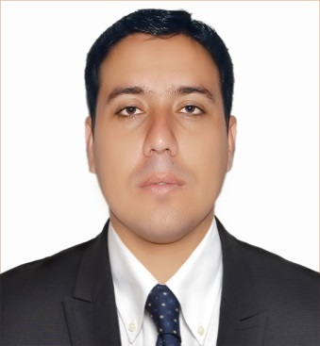
ZIA
Email: zia.345322@2freemail.com
Cell UAE: +971505891826

Career Objective
Seeking a responsible position in a professional office environment
Academic Education

- MBA (Supply Chain Management)
Indus University Karachi, Pakistan (2013-2016)

- Bachelors of Economics (2009-2011)
Federal Urdu university Abdulhaq campus, Karachi, Pakistan

- Intermediate (Inter Science 2007)
Board of intermediate education Malakand.

- Matriculations (2005)
Board of intermediate education Malakand.
Professional Certifications and Diplomas

- Hotel management diploma Sep 2009 – March 2011P.I.T.H.M Clifton, Karachi

- Fidelio course March 2011 – May 2011 P.I.T.H.M Clifton, Karachi

- D.I.T(2015-2016)
Father institute M.T Khan Road Sultanabad Karachi.

Professional Work Experience
- Oxford high school, Karachi. (May2013-May2014)
Served as full-time subject specialist teacherinstructing all academic subject areas from grade 5 to grade 10th students
Key Contributions:
- Earned high marks for the quality and creativity of classroom teaching
- Taught general education students as well as individuals with learning challenges
- Actively served on a variety of school committees and task forces.
- Established positive relationships with students, parents &staff
- OPTP RESTURANT, KARACHI. (JUNE 2014-DEC2014)
As Management Trainee Manager responsible for working alongside Senior managers and accepting delegated responsibilities and duties.
Key Responsibilities:
- Evaluate work output.
- Work in different departments to gain perspective, including marketing, sales, customer services, purchasing, merchandising, and personnel departments.
- Handle established accounts to gain familiarity.

Key Skills
- Computer Skills: Excellent command over MS Word, MS Excel, PowerPoint & good typing skills
- Linguistic Skills: Fluent in English and Urdu.
- Additional Skills: Able to delegate, above average grasp of new systems and work environments, work well with people of diverse backgrounds. Excellent report writing skills developed through extensive academic and professional assignments

Hobbies & Interests
- Reading literature, new technologies &nature’s Facts.
- Electronic Media.
- Listening Music.

PERSONAL PROFILE

Religion : Islam
Gender : Male
Date of Birth : April 06, 1989
Marital Status : Single
Languages Know As :English ,Urdu &pushto
Nationality : Pakistani

