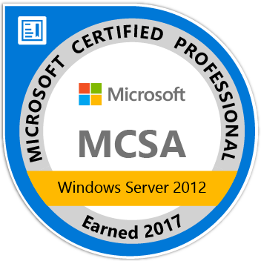 | MASVOOTH  C/o- +971502360357  masvooth.345331@2freemail.com  Chennai, India.  VISA STATUS: VISIT DUBAI. | 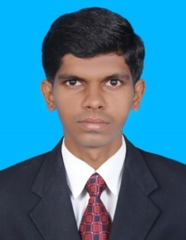
CAREER OBJECTIVE:
To work in learning and challenging environment, utilizing my skills and knowledge to be the best of my abilities and contribute positively to my personal growth as well as growth of the organization.

PROFESSIONAL CERTIFICATION:

- Microsoft Certified Professional (MCP) Windows 2012 MC ID: 13131032.
- Microsoft Certified Solution Associate (MCSA) Windows 2012MC ID: 13131032.
- Advanced Diploma in CCTV& Access control Training.

PROFESSIONAL SUMMARY:

- 4+ years of experience in IT SUPPORT ENGINEER &SYSTEM ADMIN.
- Good experience in Servers, desktop, laptop, printer, outlook, backup, antivirus and hardware networking.
- Good Knowledge in Active Directory (AD), DHCP, DNS, DFS, WDS, GPO.
- Good experience in CCTV & Access control systems

EDUCATIONAL PROFILE:

- B.E(Electronicsand CommunicationEngineering),India  AAMEngineeringCollege (AnnaUniversityChennai),India | 6.5CGPA | 2012
- HigherSecondary Course (HSC),India  S.I[BMS]HigherSecondarySchool, TamilNadu,India | 71.7% | 2008
- Secondary SchoolLeaving Certificates, India  S.I[BMS]HigherSecondarySchool,TamilNadu,India | 80% | 2006

PROFESSIONAL EXPREIENCE :

Company : APEX Services.
Designation : System Admin.
Duration :June2016 to February 2017.

Company : Precision Tech-serve Chennai.
Designation : Windows Admin.
Duration :1 Year 6 Months (July2014 to Jan2016).

Company :ADS InfoTech
Designation :IT Support Engineer.
Duration :2 Years (June2012 to July2014).

Responsibilities in Apex Service:

- Installing, Configuring and Administering of Windows server 2003, 2008 & 2012.
- Managing Active Directory User Accounts, Groups and Organizational Units
- Adding, removing, updating user account information & resetting passwords, etc.
- Creating and Managing User Profiles (Local, Roaming & Mandatory).
- AD backup & restore.
- Managing and monitoring DHCP server (IP reservation, scope & DHCP backup & restore).
- Creating and managing security groups and providing various level of access to File and folder based on Requirement.
- Configure sharing & security permissions.
- Managing file servers.
- Configuring and Administering of GPO.
- Hardware up gradation and Role Migration on the servers
- Checking the health of the servers and reporting to manager.
- Resolve alerts indicating Low Disk space, High Memory and CPU usage, Server Performance issues, File Replication, and Service issues etc.,
- End user support

Responsibilities in Precision Tech serve:

- Providing desktop level solutions to end user.
- Installation of operating systems like Windows 10, Windows 8, Windows 7, Windows XP, Windows 2008.
- Trouble shooting the Operating system and application software.
- Troubleshooting OS related issues like System not booting, System Hangs, Repeated reboot and Blue screen Error.
- Install and configure mail clients like Microsoft outlook and troubleshooting Outlook related issues like send/receive not happens, outlook get hangs.
- Configuring Personal Storage Table (PST) in Outlook.
- Installing and configuring printers and troubleshoot printer issues like paper jam, toner replacement.
- Providing windows Security, Antivirus Patch Updating, Backup and Recovery.
- Maintaining inventory of all Users, Systems, Network connectivity, and IP details.
- Diagnosis and providing support for network connectivity issues.
- Managing and Maintenance of LAN and basic level network troubleshooting.
- Implementing and Troubleshooting of login scripts for drive mappings.
- Coordinating with Vendors HP, DELL to resolve the hardware related problems.
- Analyze the root cause for critical problems and providing the appropriate solution to avoid the reoccurrence of the problem.
- Basic knowledge in Exchange, VMware & citrix.

Responsibilities in Ads:

- Operating systems and applications installation.
- Hardware and software troubleshooting.
- Resolving all kinds of hardware problems like disk drive, mother board, RAM, CPU, NIC, power supply, etc...
- Configure the DVR systems for monitoring
- Install CCTV, Access control and security systems according to specified standards.
- Test systems and train CCTV operators on its functions and provide manuals and procedures when needed.
- Providing ongoing service, repair and maintenance of varied CCTV systems within the area.
- Assured that all CCTV in the facility are running in good working conditions.
- Perform routine CCTV maintenance services

PERSONAL PROFILE:

Date of birth | : June 1990
Language Known | : English, Tamil |  | Passport Expiry | : Sep-2022
Marital Status | : Single |  | Gender | : Male

DECLARATION:

I hereby declare that the information’s furnished above are true to the best of my knowledge.

