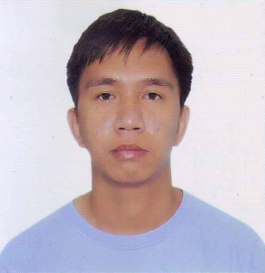
Jessie

Email: Jessie.345436@2freemail.com
Date of birth: June 14,1987
Place of birth: Sta. Rosa, Nueva Ecija
Nationality: Filipino
Visa statue: Visit Visa
Marital status: Married
Objective

To be able to work in a fast developing professional environment, where I can get the opportunity to learn and enhance my acquired experience and capabilities and to become a team player for the achievement of the organizational goals with a strong belief in coordinated team effort and proof to be an asset for its effective functioning.

Educational Attainment

Secondary
Carmen National High School
Zaragosa, Nueva Ecija
S.Y. 2006-2007
Primary
Rajal Centro Elementary School
Sta. Rosa, Nueva Ecija
S.Y 1999-2000

Working Experience
BASILICO RESTAURANT
Dubai Marina
Barista cum waiter
January 2010-July 2011

➢ Greet customers and seat them according to their preferences
➢ Offer welcome drinks and beverages
➢ Fill water glasses and refill beverages
➢ Take orders and provide information about menu items
➢ Suggest menu items when requested by the customer
➢ Ensure that the order is prepared according to the menu
➢ Clear table and clean table tops
➢ Change table cloths and clear dishes and flatware
➢ Change table cloths and clear dishes and flatware
➢ Carry dishes and flatware to the kitchen
➢ Ensure that all tables replenished with eating dishes
➢ Collect menus at the end of the shift

Sand and Gravel Company
Company Driver
August 2011- November 2015

➢ Transport loose materials like gravel, rock, sand and dirt to required destinations
➢ Follow a schedule to ensure timely delivery
➢ Chart out the best route possible in order to save time
➢ Verify the types of materials being loaded on vehicle
➢ Perform appropriate maintenance and keep truck clean
➢ Ensure that all deliveries have been signed and delivered to the correct recipient
➢ Perform loading and unloading duties
➢ Manage daily inspections on the vehicle

Veejay Restaurant and Catering Services
Waiter
December 2016- present

➢ Greet guests and make them feel comfortable.
➢ Learn menu items and be able to describe them appropriately to guests.
➢ Take beverage and food orders.
➢ Deliver beverages and food in a timely manner.
➢ Check-in with guests to ensure that everything is going well.
➢ Clear dirty dishes from table.
➢ Refill beverages throughout the meal.
➢ Deliver guest’s bill and thank them for dining at the restaurant.
Work with other servers and be a team player

I hereby certify that the above information is true and correct to the best of my knowledge and belief

JESSIE

