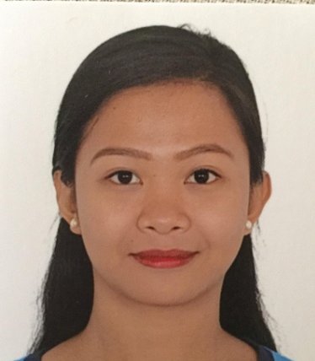
Ruby
Ruby.345486@2freemail.com

Objective: Ambitious newly qualified Dentist with excellent organizational and interpersonal skills, keen to secure a position in the field of dental industry with a dynamic and progressive dental practice. Ideal candidate for position requiring drive, initiative, responsibility and challenge

EMPLOYMENT EXPERIENCES

Associate Dentist

DentPro Diagnostic and Dental Center
Iloilo, Philippines
August 5, 2016 – October 15, 2016

- Completely and accurately obtain information in a courteous and respectful manner in order to determine an appropriate treatment plan
- Provide professional dental services and care for patient
- Examining patient’s oral cavity and diagnosing their dental condition
- Creating detailed treatment plans and gaining patient commitment
- Execution of treatment quickly, efficiently, and accurately including performing Oral Prophylaxis, Extraction, Cosmetic Repairs, Prosthetics, Bridges/ Crowns and Endodontic Treatments while keeping the patient informed , and being sensitive to patient comfort during the treatment
- Set the expectation with the patient by listening to their concerns and addressing those that can be addressed and informing the patient the course of action to follow for other health concerns
- Communicate effectively with the dental staff, other health care providers and patients
- Work in coordination with other clinic staff to effectively educate the patient on their course of treatment in order to increase the likelihood of compliance

LICENSURE:

Republic of the Philippines
Professional Regulation and Commission
Board of Dentistry
Licensed Dentist

EDUCATIONAL BACKGROUND

(Degree Holder/Graduate)
Iloilo Doctors’ College
College of Dentistry
Doctor of Dental Medicine

Clinical Training
Iloilo Doctors’ College
Dental Clinic
June 2013 – March 2015

- Assigned quota of clinical requirements to be completed over two- year period which included all aspect of dentistry
- Providing your own patient for dental treatment and contacting them by appointment card or by phone
- Performed clinical assessment on patients- discussed treatment options and decides the best treatment plan taking into account the factors including time, cost, age and medical history of the patient
- Held weekly pediatric sessions and performed procedures on children
- Developed excellent patient care skills

Special Skills

- Performed ALVEOPLASTY, GINGIVECTOMY, ODONTECTOMY AND APICOECTOMY
- Experienced in handling pediatric dental patients
- Computer Literate knows how to operate computers and can make any paper works. Able to work in office.
- With knowledge in Microsoft Excel & word.
- Can speak English and understands English fluently.
- Can work under pressure and flexible in time schedules.

PERSONAL INFORMATION

Birthdates August 22, 1993
Nationality Filipino
Sex Female
Height 5’5
Civil Status Single
Age 23 years old
Visa Status Long term tourist visa

References
Available upon request

I hereby attest that the above information is true and to the best of my knowledge…

