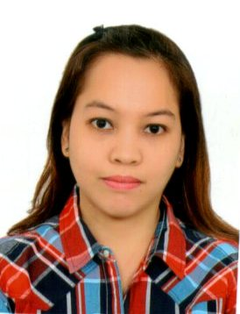
MARIA
maria.345534@2freemail.com

OBJECTIVE To have a challenging and rewarding career. To join an organization that provides an excellent work environment for growth and development.

WORK EXPERIENCE

June 30, 2016 – Mar. 17, 2017 IN HOUSE PROPERTY CONSULTANT
DMCI HOMES CORPORATE CENTER
1321 Apolinario St. Bangkal, Makati City, Metro Manila, Philippines

Jan. 30, 2008 – Jan. 4, 2012 TEACHER
JESUS IS LORD CHRISTIAN SCHOOL TAGUIG PATEROS INC.
77 Sampaloc Extension Zone 1 Signal Village Taguig City, Philippines

March 2006 – Feb. 2007 DENTAL TECHNICIAN (Opaque)
EMPRESS Dental Laboratories Inc.
5th Floor Net 1 Crescent Building 26th St., 3rd Avenue Crescent Park
Fort Bonifacio Taguig City, Philippines

April 2005 – March 2006 ASSISTANT TEACHER (Preschool)
D.F. Tinker Bell School
77 Gen. Espino St., Zone 4, Signal Village Taguig City

EDUCATIONAL BACKGROUND

2000-2005 RIZAL TECHNOLOGICAL UNIVERSITY - MANDALUYONG
Bachelor of Science in Secondary Education
Major in General Science
Graduate

1996-2000 SIGNAL VILLAGE NATIONAL HIGHSCHOOL
Graduate

1991-1996 SOUTHEASTERN COLLEGE
Graduate

PERSONAL BACKGROUND

Born on June 29, 1983 in Signal Village Taguig City.

Fluent in English and Filipino.

Knowledgeable in MICROSOFT WORD AND POWERPOINT.

Interests include sports, cooking/baking and designing.

Skills include planning, organizing, and coordinating.

Responsible, eager, flexible, dedicated and results-oriented.

SEMINARS ATTENDED

DMCI HOMES PROPERTY INC.
Property Consultant
Bangkal St., Maakati City
June 2016

JILCF TEACHERS’ CONVENTION
Strategical Ways of Teaching
Bunlo, Bocaue Bulacan
May 2009

JILCS ENGLISH AND MATHEMATICS SEMINAR
Sampaloc Ext., Signal Village Taguig City
May 2008

W.A.V.E. (Work, Ability, Value, Equipment)
To enhance, work quality and value
May 2006

