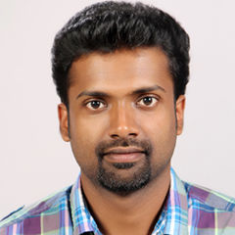
RESUME

E-MAIL- ID: jeevan.345604@2freemail.com
Sharjah UAE

Languages known: English, Malayalam & Hindi
Nationality: Indian
Gender: Male
Marital status: Married

Have a valid UAE Driving licence

JEEVAN

CAREER OBJECTIVE
Seek to work in an environment that will challenge me further while allowing me to contribute to the continued growth and success of the organization
CAREER SUMMARY
An experienced senior sales executive with a consistent track record of successfully employing best business practices that improve efficiency, Possessing excellent communication, leadership and organizational skills, is presently looking for a Sales job in a forward moving company.
AREAS OF EXPERTISE
Marketing, Identifying opportunities, Sales, Monitoring Competitors, Brand Analysis, Advertising promotion, Driving Profitability Implementing Action Plans, Event Management, Maintain customer relationship

CAREER HISTORY
- Working as a store keeper at Sharjah Golf and Shooting club from 2015 march 1
- Assisting the Manager with the coordination of maintenance staff
- Keeping the stock for the maintenance items using SAP(Systems, Applications, Products in data processing)
- Worked as a Senior Sales Executive at Kores India Limited from 2013 Feb 1 to 2015 Jan 1
- Assisting the marketing manager and support the marketing team with marketing activities.
- Extensive Follow-ups along with maintaining of Customer Data.
- Gathering market and customer information.
- Preparing/Updating Market Survey Reports.
- Providing Sales and After Sales Support to Clients

EDUCATIONAL QUALIFICATION:
- Master of Business Administration specialised in Marketing & Human resource from Mahatma Gandhi University 2010-12
- Bachelor in Arts& literature from Mahatma Gandhi University 2008-10
DECLARATION
I do here by declare that all particulars furnished above are true to the best of my knowledge and belief.

