 | 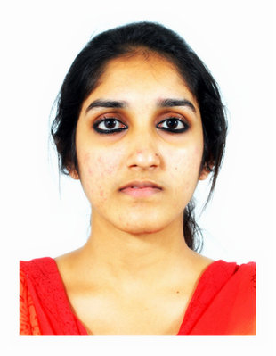  POOJA  Personal Data:  Date of Birth: 20-11-1993  Sex: Female  Nationality: Indian  Marital Status: Single  Birth Place: Ernakulam  e-mail:  pooja.345912@2freemail.com | CAREER OBJECTIVE  To become a professional and achieve quality and excellence in all aspects of my career,benefitting the overall development of the organization where I am employed  ACADEMIC QUALIFICATION  COURSE UNIVERSITY INSTITUTION YEAR OF PASSI-NG PERCENTA-GE  B.Tech - Civil Engineering M.G University SreeNarayana Gurukulam College Of Engineering 2015 CGPA- 7.17/10  Higher Secondary Board Of Higher Secondary Examination Model Technical Higher Secondary School,Kaloor, Ernakulam 2011 87.35%  SSLC Kerala Board Of Public Examination St.Teresas Convent Girls Higher Secondary School, Ernakulam 2009 82%  MAIN PROJECT  Feasibility study of light weight brick (LWB):Recycling wastes by incorporating them into building materials is a practical solution for pollution problems. This project studied the feasibility of LWB by replacing brick earth at different percentages by pre-treated rice husk and saw dust. This would help to reduce depletion of brick earth and raw materials used in cement, increases sound insulation properties and decreases thermal conductivity in buildings, reduces dead load on foundation and more.  SEMINAR  River linking: Water availability is becoming dearer and dearer day by day in India due to monsoon vagaries and increasing population propulsion.Ultimately the National Water Development Authority (NWDA) made thorough study, which indicated that Himalayan Rivers, have exceedingly surplus quantum of water and hence proposed transfer of these surplus basins to water deficit basins in peninsular region. We opine that the areas of dry land to be converted into wetland and areas of unproductive land to be converted to agricultural land are far more than the land to be lost due to canals and reservoirs.  TECHNICAL SKILLS  - Computer Knowledge: MS Word, MS Power point and good typing speed  - Softwares : Autocad, Revit Arch, 3ds max
ACHIEVEMENTS AND ACTIVITIES
Registeredas ENGINEER-A under the provisions of the KERALA MUNCIPALITY BUILDING
RULES,1999 (Reg No: G6–2019/16/220/EA)
- Co-ordinator, CHRYSALIZ -Placement Cell SNGCE
- Participated a course of Legal Literacy based on “Niyamapaddam” held by District Legal Services Authority
- Participated and won prizes in International Olympiad of Mathematics.

TRAINING
- Attended 3 months training under Asset Hoomes, the responsible builders, Cochin ( As Site Engineer Trainee)
- Attended 10 days training under Nest-Infratech (on the site - JKH Signature, Thottumugham, Aluva)
- Attended National Conference on Trends and Recent Advances in Civil Engineering organized by Sree Narayana Gurukulam College of Engineering, in the Year 2014.

WORK EXPERIENCE
- 1 year experience as Autocad drafter, MANASARA CONSULTANTS, KALOOR, ERNAKULAM
- 1 year experience as CIVIL SOFTWARE FACULTY, CADD CENTRE TRAINING SERVICES, PALARIVATTOM, ERNAKULAM

AREA OF INTEREST
- Software
- Construction work
- Engineering drawing

LANGUAGES KNOWN
- English
- Malayalam

DECLARATION
I hereby declare that all the above furnished details are true to the best of my knowledge and belief.

PLACE: ERNAKULAM POOJA

