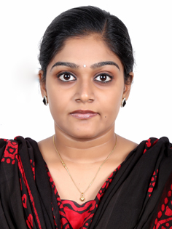
Ashwini
Ashwini.345949@2freemail.com
OBJECTIVE

To work in a dynamic environment with growth potential where creativity, hard work, team spirit, dedication & sincerity are appreciated, where I can utilize my professional skills.
EDUCATIONAL QUALIFICATION

B-tech (Bachelor of Technology) (2009-2013)
Electronics and communicational engineering.
Ellenki College of Engineering for Women, Hyderabad.
Jawaharlal Nehru Institute of Technology University, Hyderabad, India
TECHNICAL CREDENTIALS
- Software : MS office tools, ORCAD
- Operating system : MS Windows XP, Windows 07/08.
- Communication Package : Internet and E-mail operation

WORK EXPERIENCE

EMPLOYER Bharti Airtel Services Limited
Designation Showroom Manager
Handling Sales and Operations
Location Kerala, India
Duration March 2014 to May 2015

Duties & Responsibilities

- Customer support, Ensuring good ambiance and proper branding.
- Well versed in telecom applications such as ICRM, IDOC, PACS, and HLR.
- Handled showroom operations and Recruitment of manpower.
- Improving the sales.
- Maintaining the data of employee’s documents such as Joining report, appraisal report and Monthly preparation of attendance sheet.
- Closely working with the HR department in Head office.
- Respond quickly and efficiently to incoming sales enquires by telephone, fax and email.
- Develop and maintain strong business partnerships with major key accounts.
- Preparing detailed quotations according to customer enquiries.
- Prepare and process the sales order.
- Update and Maintain delivery schedules.
- Preparing delivery order and coordinating with customer on material deliveries.
- Communicate with sales manager regarding sales order &delivery status
- Coordinating with internal departments and resolving problem.
- Maintain current and accurate customer files and information.
- Communicate with customers on, to update on order status or any other pending matters and coordinate with Purchase Department to assist purchase priority list for the management, and liaise with purchase department on any special requirement of the customer.
- Educate Customers regarding the products and services.
- Present and explain products and services to clients and assist in meeting their needs.
- Answer questions and solve problems for clients by listening, collecting data, and securing answers.
- Resolve client requests and questions promptly, courteously, and professionally.
- Identify, research, and resolve customer issues using the advanced process and tools.
- Giving maximum productivity by attending more calls and resolving the customers issue / queries in less time.

DECLARATION
The above mentioned information is true to the best of my knowledge and authenticity of my credentials can be verified upon request. References can also be provided upon request.

