Shubha.345960@2freemail.com 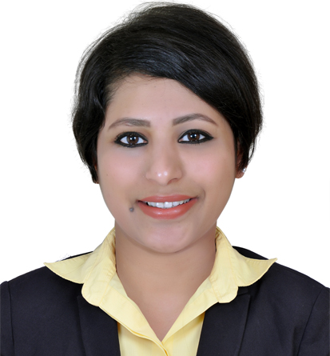

PROFILE SUMMARY

A hardworking person with more than seven years of extensive experience in working as Front Office executive, data analyst and backend HR. Excellent verbal and written communication skills with the ability to interact efficiently . Ability to function in a multi-cultural working environment. A good team player who ensures the best performance from the team through motivation, training and mentoring. Academic qualifications include BA, Microsoft Word, Excel and Outlook Express.

PROFESSIONAL EXPERIENCE

Company | Designation | Duration
NMC Specialty Hospital, Dubai | Front Office Executive | 2 years
Concentrix /Tech Bridge, India | Data Analyst | 5 years
Accenture , Bangalore, India | Process Associate | 2 years

JOB RESPONSIBILITIES IN DETAIL

- NMC Speciality hospital.(Dubai)
- Employed as Front office executive
- Responsible for Front office operation which includes OPD reception, Laboratory, Information Desk
- Information desk: Greeting the patients, answering queries, guiding them to right department. Booking and cancellation of appointments.
- OPD reception: Responsibilities include opening new files for patients and steps in executing the appointments.
- Coordinate with the doctors regarding patient arrival and also handing over the call back requests from the patients.
- Retrieving the patient file when requested by the doctor.
- Coordinating with the insurance department for patient insurance related queries.
- Maintaining the data sheet for the number of patients received, cancelled appointments and elapsed patients.
- Checking the insurance claim forms end of the day to ensure that the insurance claim process is operated smoothly.
- Appointment Desk: Answering the calls for booking and cancellation of appointments.
- Answering queries related to insurance
- Operator: Connecting internal and external calls to the required departments.
- Online request: handling the online requests for queries, booking and cancellation of appointments.
- Guest relation: Guiding the patients to required departments ensuring that patient’s needs are attended to promptly.
- Laboratory: Checking if approvals are required for lab tests, entry of lab tests in the system, and managing the cash counter ensuring that cash and credit tally end of the day.

- Concentrix/Techbridge/VMware (Bangalore, India)
- Employed as Data Analyst
- Data Matching: Linking a lead with a customer record and create a “Best Record
- Data from different source system EBS/SIEBEL/SFDC to UCM.The purpose to have a centralized database system from which the data can be leveraged to different workgroups.
- Cleansing, standardizing and de-duplicating customer data, Update source records as needed based on documented data maintenance processes Troubleshooting issues related to VPN
- Partner Operation - New Account Validation Advantage+
- Advantage+ is VMware’s Opportunity Registration program which rewards partners for exhibiting desired sales behaviors, bringing in new opportunities, and value-selling by educating customers and prospects about VMware Implementing access control via Active Directory.
- Assigning data sheet to the team
- Quality check for the daily data received.

- Accenture Human Resource Services (AHRS) (Bangalore, India)
- Answering calls and resolving their queries
- Booking delegates for training and maintaining their training records
- Arranging for the delegate’s transport and accommodation.
- Giving them information on the various courses available for various occupational classes.
- Maintain their attendance.
- Update their HR Status as requested by the clients.
- Sending the course invites.
- Communicating with the employees as required regarding their interview status
- Creating letters for the candidates who apply for job
- Creating memos for selected and rejected candidates
- Maintaining their interview scores in client applications
- Update their HR Status as requested by the clients
- Quality checks for recruitment work
- Quality checks for Training work
- Creating Organizational Charts for the client.
- Maintaining files of all the candidates and updating the details for the candidate.

NOTEABLE ACHIEVEMENTS

- Numero Uno award in accenture
- Best Employee of the month for 3 months in concentrix.

EDUCATIONAL QUALIFICATIONS & CERTIFICATIONS

Degree Awarded | Name of Institution/University | Grade/Class obtained
BA- Arts | Besant Women’s College, Karnataka, India. | First Class
All India Secondary School Examination | Sri Ramakrishna Pre University College | First Class
School (Pre Primary) | Sri Ramakrishna English Medium High school, India | Distinction

PERSONAL DETAILS

D.O.B : 1st February 1985
Gender : Female
Marital Status : Married

DECLARATION

I hereby declare that the information furnished above is true to the best of my knowledge.

Place: Dubai

