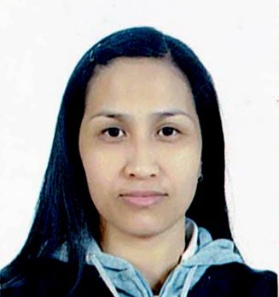

Julie
Julie.346034@2freemail.com

Objective:
To utilized my skills, knowledge, and ability for the benefit of myself, coworkers, clients and for the company. By applying my personal qualities as an energetic, hard worker and team player, with a positive attitude, and well-rounded background. My experience ranges from serving the customer directly dealing with the supplier. I am sure my skills would be a beneficial assets to any organization.

Work experience:

Service crew /hostess: First Cup Masaya Restaurant and Café Dubai, United Arab Emirates
(Oct. 2014- Sept. 2015)
Welcome and greet customers as they come into the restaurant and help them to settle down and also take their orders.
Serves client/customers in an effective manner and in strict accordance.

Volunteer/nursing assistant: Veterans Memorial Medical Center
(March 2013- March 2014)
On the job training. Assisting patients with their medical needs e.g. getting vital signs, assisting in giving prescriptions, giving bed baths to the bed ridden patients and first aider.
Participating in Medical and Dental Missions.

Personal care giver (special patient): Guya-Castro Residence, Ilocos Norte Phils.
(April- August 2014)
Over all task for the patient.

Housekeeping: Riyadh, Saudi Arabia
(Dec. 2010- January 2013)
Ensuring cleanliness and organization of the apartments

Business Woman: JDCastro Gen. Merchandise: Wholesaler and Retailer Caa Las Pinas City Phils.
(May 2009-present)
Undertakes and operates enterprises and assumes some accountability
Establish to offer a new or existing product

Sales Associate: Hang Ten Robinsons Mall Laoag City
(July 2008- July 2009)
Provide customer satisfaction by handling orders and request from clients
Ensure timely product preparation and availability

Marketing Assistant Manager: Jollibee Company Owned Laoag City
(June 2007- June 2008)
Communicating with clients, organizing market research
Writing press releases, arranging promotional events.
Assisting the manager in writing reports and analyzing data.

Service Crew/Party Hosting: Jollibee Company Owned Laoag City
(June 2006- June 2007)
Assess customer needs and provide complete service while maximizing sales.
Maintain and improve store standards. Maintain sanitary work environment.
Process delivers and excellent guest satisfaction

Internship:

Housekeeping: Palazzo De Laoag Hotel/Bar. Ilocos Norte Phils.
(Jan- March 2010)
Maintain customer relations and satisfaction with wide range of clients.

Food and beverage: Palazzo De Laoag Hotel/Bar. Ilocos Norte Phils.
(July- Sept. 2010)
Ensure that every guest receive the great satisfaction in their food and drinks and the service for their entire dining experienced.

Educational:

Vocational: Health Care Services Prima Care Training and Development Center LaoagCity Phils.
(SY 2013-2014)

Housekeeping/F&B: TESDA Intramuros Manila Phils. 2010

College: Bachelor of Science in Tourism. North Western University Laoag City, Ilocos Norte Phils.
(SY 2003-2005)

I view myself as a mature, motivated and self-disciplined person, eager to learn the unknown and apply my knowledge and skills to each and everything I do. I am a team player with an ability to mix people. I look forward to challenges and enjoy working in a competitive environment to be associated with a progressive organization that gives me the responsibilities to apply my knowledge and skills and be involved as a part of the team that dynamically works towards organization.

I hereby certify that the above information is accurate and true to the best of my knowledge.

