AQEEL
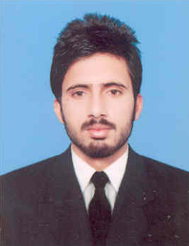
PERSONAL INFORMATION
DATE OF BIRTH: 07-08-1991
NATIONALITY: PAKISTANI
EMAIL: aqeel.346121@2freemail.com

CAREER OBJECTIVE
To work in an organization that offers a creative, dynamic and professional environment, where my professional skills and proven abilities can be fully applied.
WORK EXPERIENCE
  - May 18-2016 to till Date; Working as PMR Coordinator. Working of ERP System, Daily base PM schedule, CM Activities and daily base reports and directly concern to Project Manager and assistant.
  - March 20-2012 To Jan 25-2014;Working as Electrical Technician (Project Of Warid Telecom) Faisalabad.
Supervising Of Emergency Team; Corrective Maintenance, Control System.
Preventive Maintenance; Couple of years Preventive Maintenance Experience of Genset Control System, Maintenance & Troubleshooting of ATS Panels, AMF panels, Isolation Transformers and Line conditioners UP to 100 kva .

Key knowledge
- Having Ability of Handle and resolve all kind of issue and problems.
- Good Experience in Electrical Control circuit, Switch gears and panel control system.
- Hand experience in ATS ,AMF control system and maintenance. Experience in Rectifier system, power supply unit, control unit, Base transmission unit and Transmission system
- Hand experience in heavy motors connection star delta DOL and reverse forwardconnections timer controls and proximity switches etc.
- Good experience of PLC system Input output and communication card.
- Working experience in ERP system
- Having ability to study to electrical drawing and work according to the drawings.
- Hand experience in electrical general maintenance and Preventive maintenance.
- Having ability to attend the breakdowns and fix the problems in swift action.
- Hand experience in diesel Generator up to 500 KVA and connectivity with synchronizer panel
- Aware of Health and safety role while working at plant.

TRAINING
40 Days Training in High-tech Networks PVT LTD Lahore. About manufacturing of ATS Panels, AMF Panels, PSU System, DTRU System, Electrical Diagram, Generator Installation, Generator Maintenance, Preventive Maintenance and Corrective Maintenance.

ACADEMICS
- B.S.C Electrical Engineering and Technology 2016.
(CGPA=3.47)
Government College University Faisalabad.
- D.A.E (Electrical) 2011. 75%
Government College of Technology Sahiwal.
P.B.T.E (Lahore)

- Metric 2008. 58%
N.A Model High SchoolSahiwal.
BISE (MULTAN)
COMPUTER SKILLS

- MS Office
- Mate Lab
- MP lab
- Proteus
- Motor master
- ERP System
REFERENCE
Reference will be provided on demand.

