Curriculum vitae

RAKESH
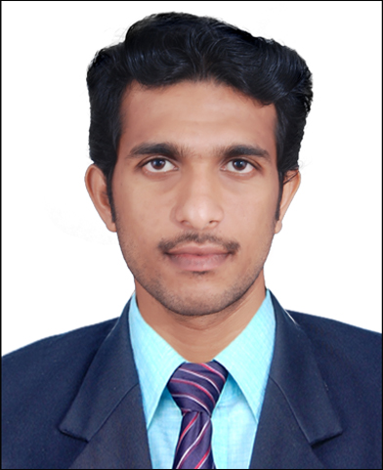

E-mail id:
Rakesh.346181@2freemail.com

Contact no:
Mob No -: C/o 0501685421

Career Objective:

- To be associated with a progressive organization, which can provide me with a dynamic work sphere to extract my inherent skills as a Professional, use and develop my aptitude to further the organization’s objectives and also attain my career targets in the progress.

Educational Qualification:

COURSE | NAME OF THE INSTITUTION | UNIVERSITY/BOARD | YEAR OF PASSING
B.E  Electronics And Instrumentation Engineering (EIE) | Maharaja engineering college,  Coimbatore. | Anna University,  Coimbatore. | 2014
Higher Secondary  Science | S.N.Vidya Bhavan Chentrapinni,  Kerala. | C B S E | 2010
S S L C | S.N.Vidya Bhavan Chentrapinni,  Kerala. | C B S E | 2008

`

PROJECT DETAILS

- Have done main project on the “IMPLEMENTATION OF AUTAMATIC TRIP FOR SULPHURIC PLANT IN DCS”
- Have done mini project on the “DIGITAL CODE LOCK FOR ELECTRIC DEVICES”.

EXPERIENCE

- Ten month experience in Bhabha Atomic research centre (BARC) as supervisor for P3A project in Kalpakkam, Chennai, Tamilnadu.
- One year experience in Bhabha Atomic research centre (BARC) as instrument technician for WIP project in Kalpakkam, Chennai, Tamilnadu.
- Undergone Post Graduate Diploma in Industrial Automation.
AREAS OF INTEREST

- Digital electronics
- Power plant engineering
- Refineries
EXTRA-CURRICULAR ACTIVITY

- Attended a workshop on PIC microcontroller conducted by IEEE.
- Attended a placement training class conducted by Key Mind. Pvt. Ltd.
- Attended IEEE- Microsoft App development Campaign.
PROFFESIONAL SKILLS AND STRENGTHS

- Commitment, Honesty, Sincerity & Hard work.
- Leadership & Teamwork.
- Ability to work under pressure of dead line.
- Result oriented, Positive and flexible.
PERSONAL DETAILS

Gender : Male
Nationality : Indian
Marital status : Single
Date of Birth : 30-04-1990
Blood Group : O +ve

I declare that the above-furnished details are true to the best of my knowledge and belief.

Place : Ajman
Date : RAKESH

