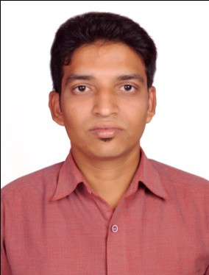
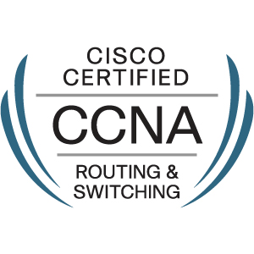
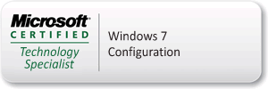
CURRICULUM VITAE
MUJEEB
Desktop Support Engineer / System Admin
Email : mujeeb.346188@2freemail.com
Mobile : C/o 0502360357

OBJECTIVE :
An ideal candidate with 2 years of experience as a Desktop Support Engineer and aimed to be a part of a dynamic and progressive organization where I can gain something and work for the growth of the organization and which would offer me challenges with a quality environment where my ideas and skills can be shared, enriched and put to maximum use.

WORK EXPERIENCE :
- Worked in a project as a Desktop Support Engineer with Vihaan IT Solutions from 04-04-2014 to 09-10-2014.
- Worked in a project of Wipro Limited as a Desktop Support Engineer (Payroll : Crown Hr Solutions Pvt., Ltd., Chennai) from 22-12-2014 to 28-05-2016.

ROLES & RESPONSIBILITIES :
- Troubleshooting and installing Hardware components.
- Installation of Operating Systems.
- Taking care of Network problems.
- Deploying softwares and keeping them updated.
- Solving customer queries rapidly.
- Troubleshooting Printer & Scanner issues.
- Assisting customer with basic queries.
- Gathering information for frequently reported issues.
- Daily check-up of server.
- Escalating issues to Supporting/concerned team.
- Quick responding to customers.

ACADEMIC QUALIFICATIONS :
- B.Sc (Computer Science) Graduate with 68.02 % in the year 2014 from Osmania University, Hyderabad, India.
- Intermediate (MPC) with 79.2% in the year 2011 from Board of Intermediate Education, Andhra Pradesh, Hyderabad, India.
- S.S.C. with 86.5% in the year 2009 from Board of Secondary School Certifications, Andhra Pradesh, Hyderabad, India.

TECHNICAL QUALIFICATION :

- Diploma JCHNE (Jetking Certified Hardware & Networking Engineer) course from Jetking Infotrain Limited, Dilsukhnagar, Hyderabad, Telangana, India.

TECHNICAL SKILLS :

- Troubleshooting and installing Hardware components (Microprocessors, RAM, Hard Disk, ODD, Monitor).
- Installing various types of Windows’s Operating System, Managing Devices using Device Manager.
- Well known with Ms-Office applications.
- Configuring email clients.
- Managing and creating several types of volumes using Disk Management.
- Working with User Account’s, configuring Network access and connect types of Network’s.
- Configuring Bit Locker Drive Encryption, configuring Offline Files.
WINDOWS SERVER 2008 :
- Installing Windows Server 2008, Configuring Disk Quota, Creating Domain
- Mapping Network Drive
- Configuring DHCP, DNS, IIS, Terminal Services, Print Services, File Services
- Certification Authority SSL,
- Applying Group Policies, Windows backup and restore.
NETWORK CONCEPTS :
- IP Addressing, IP Routing
- Basic router configuration.
- Access-list, NAT/PAT, V-LAN.
CERTIFICATIONS :

- MCTS Certified in configuring Windows 7 Operating System.
Certification Number : F025-5281.
- CCNA Certified. CISCO Id : CSCO1301471
Certificate Verification Number : 425406799190DLCF.

KEY STRENGTHS :

- Quick grasper.
- Dedication and Positive attitude.
- Ability to work in group as well as independently with responsibility.
- Hard working and passion to succeed.
- Self motivated and can work under pressure.

PERSONAL INFORMATION :
Name : MUJEEB
Date of Birth : 16-02-1993
Nationality : Indian
Religion : Muslim
Gender : Male
Marital Status : Married
Languages Known : English, Hindi and Telugu

DECLARATION :
I hereby declare that the given information is true and correct to the best of my knowledge.

(MUJEEB)

