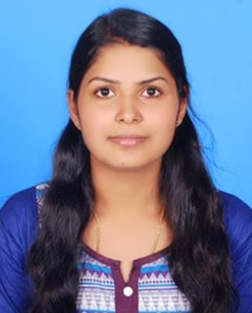CAREER OBJECTIVE:

SHABEENA

M-tech Computer Science Engineering
E.mail:
shabeena.346307@2freemail.com
Mob: C/o 0502360357

PERSONAL DETAILS

Date of Birth :02/11/1992 Gender :Female Marital Status :Single
Languages known :English,Kannada,
Malayalam
Interests :Music,Cook,Dance, Books

To work in a globally competitive environment on challenging assignments that shall yield the benefits of the job satisfaction and a steady paced professional gowth.

EXPERIENCE
- Pepperfry.com Online Shopping Promoter 10th September 2015 to 10th December 2015
Cochin international airport, Nedumbassri, Cochin
- Spicejet airline Customer Service Executive 25th February 2016 to 1st January 2017
Cochin international airport, Nedumbasseri, Cochin

PROJECT HANDELED

M-TECH PROJECT
Automatic Medical Disease Treatment System Using Data Mining
Technology Used: Java,Windows
SEMINAR

Data Mining With Big Data

B.E MAIN PROJECT
Mobile Based Lan Monitoring And Control
Technology Used: Java Windows
MINI PROJECT

Snake Game
Technology Used: C,Windows
SEMINAR

Gesture Recognition And Technology

EDUCATIONAL QUALIFICATION:

‘’’’’’’’’’’’’’’’’’’’’’’’’’’’’’’’’’’’’’’’’’’’’’’’’’’’’’’’’’’’’’’’’’’’ ’’’’’’’’’’’’’’’’’’’’’’’’’’’’’’’’’’’’’’’’’’’

’’’’’’’’’’’’’’’’’’’’’’’’’’’’’’’’’’’’’’’’’’’’’’’’’’’’’’’
    - M-TECH COMPUTER SCIENCE AND ENGINEERING

Vimaljyothi engineering college,Chemperi Kannur University
Kannur,Kerala,India May 2016

- B.E COMPUTER SCIENCE AND ENGINEERING

Vivekananda college of Engineering Visvesvaraya University Puttur,Karnataka,India
June 2014

SOFT SKILLS:
  - Good team player and have excellent interaction skill to coordinate and work within team.
  - Good problem solving ability
  - Creative thinking and applying lesson learned
  - Highily motivated for career advancement
  - Debating and presenation skill
  - Plan,organize multiple tasks and accepting feedback for effective future work

ADDITIONAL SKILL

- C,C++,Data structure,
- JAVA language
- HTML
- Database management system
- NS2,PHP

AWARDS AND ACHIEVEMENTS

- Volunteer in College Departmental Techfest, 2012
- Participation in Workshop & Competition organised by Techunt 2013
- Computer Society Of India Participated in college level technical events
- Participation in the internet of things workshop conducted by IEEE computer society,2014
- Participation in national level faculty development programme on Scope of Research in Natural Language Processing,2015

DECLARATION

I hereby declare that the information furnished above is true to the best of my knowledge

Place: DUBAI SHABEENA

Date:

