POONAM
“Productive, dynamic and ambitious individual seeking a position with Airlines utilizing exceptional customer service and hospitality skills to maximize the
satisfaction of passengers and increase repute of employer”

- Extensive background with sound understanding of the basic framework of Airlines
- Possess an integrated set of competencies that encompasses area related to Customer Service and Flight emergencies
Poonam.346373@2freemail.com

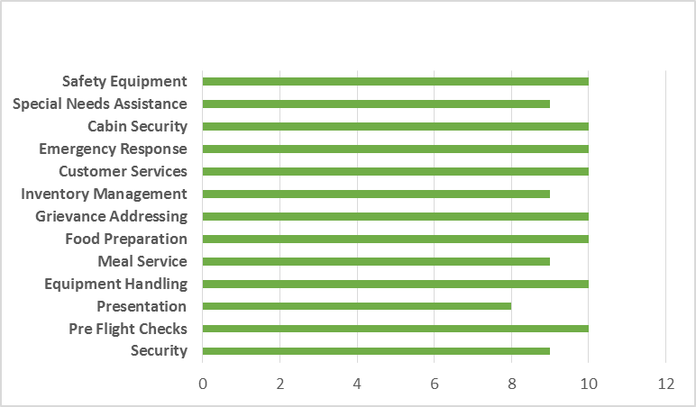
A well-presented, articulate and confident individual with 12 years of experience a proven ability to provide exceptional customer service and ensure that passengers leave with a lasting positive impression of their flight. Currently linked with Air India as a Deputy Chief Cabin Crew.

Having an outgoing personality, good interpersonal skills and the ability to work in a multi-national team environment with confidence and minimal supervision. Competent at providing leadership by responding to a variety of emergency and non-emergency situations.Demonstrated ability to respond to medical emergencies and administer First Aid and CPR. Proficient in maintaining order when dealing with angry passengers

Proficient in providing exceptional on board` service while remaining in the boundaries defined by airline. Well-versed in carrying out pre and post flight checks to ensure constant passenger service throughout the flight. Well spoken, approachable, with great attention to detail & a professional attitude.
PROFILE SUMMARY
CORE COMPETENCIES

- MBA in HR from Sikkim Manipal University in 2011
- Diploma in Travel and Tourism from South Delhi Polytechnic for Women, New Delhi in 2003
- BA in Political Science (Hons.) from Delhi University in 2002
Training Undergone:
- Cabin crew in-charge training
- Eligible of taking flight checks for new joining
- License for SEP training on A321, A320, A319
- Air restraint and ditching evacuation training
- Effective service language course (for service recovery)
- Responsible alcohol service skills and service design team
ACADEMIC

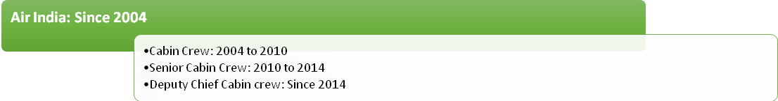
CAREER GRAPH

Responsible for making passengers feel their holiday has started the moment they step on the aircraft. Making them feel relaxed, safe and comfortable while providing a full range of in-flight services and refreshments.
Key Accountabilities:
- Welcome passengers as they arrive and check their tickets. Assist passengers in finding their seat and escort them to their seats. Ascertained that all passengers are safely seated and belted in.
- Helping children and the elderly to embark and disembark by providing physical assistance.
- Demonstrating the use of safety equipment such as oxygen masks and providing advice on what to do during emergency situations.
- Responsible for the safety and comfort of passengers. Doing routine safety checks before take-off.
- Welcoming passengers as they board the plane and helping them find their seats. Attending pre-flight briefings.
- Helping passengers load and also unload luggage from the overhead lockers. Dealing with high-net worth individuals in a professional and mature manor.
- Making sure that the aero plane is clean and tidy before passengers come on board. Prior to take off making sure all passengers have their seat belts on.
- Demonstrating the safety procedures to follow in an emergency situation. Contributing to a customer’s in-flight experience.
- Attending medical casualties like stretcher cases, pregnant women, Heart patients, Accidental cases etc.
- Circulating and collecting customs and immigration documents from passengers. At the end of a journey completing a flight report recording any incidents.
- Serving meals and drinks to the passengers throughout the flight. Dealing with difficult passengers & situations politely but firmly.
Achievements:
- Numerous letters of appreciations, complementary letters and passenger comments for exemplary service providing to the customer on many occasions.
- Complementary survey form for outstanding services providing to the customers.
- Received many appreciation letters from the department for the best uniform turnout.
- Worked as a Cabin Crew in-charge since 2008.
- Appointed as a team member of many VVIP flights.
- Confidently handled 3-4 ground emergency evacuations.

Date of Birth: 17th October 1981
Languages Known: English and Hindi
Present Address: CBD 14, Flat No-512, International City Dubai
PERSONAL DOSSIER

