MARC
Marc.346448@2freemail.com

OBJECTIVES:
To work in a challenging environment where I could be able to expand my experiences and enhance my knowledge. To be a part of an organization that is dynamic or competitive, providing the best possible opportunities and to secure a position that matches my skills; optimizing proficient and personal growth for advancement in different fields.

KEY SKILLS:
- Strong communication, motivated discipline, Professionalism.
- Computer literate,
- Know how to read Electrical schematic drawing, line diagram, blue print.
- Specialized in construction electrical works, Telecommunication, fire alarm system and HVAC.

PROFESSIONAL EXPERIENCE:
BUTEC Co. (Shah, Abu Dhabi UAE) June 2016 – January 2017
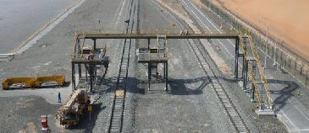

Project: Shah Sulphur Station and Pipeline project
Scope: Design and Construction of Chemical offloading bays

And Railways Crossover Bridge

Highlights:
Installation of CCTV, cable pulling of fiber optic and LV cable. Installation for the Crossover Bridge of lighting and camera. Installation of cathode protection. Glanding and termination.

Key Responsibilities for Electrical Foreman
- Coordinate with the site engineer about the priorities of the work.
- Proper tool box talk to the worker before start the work.
- Coordinate to the store man about the materials to be used in site.
- Make sure all tools and equipment are in proper condition.
- Maintain the time management of the work.
- Supervise all the workers, sub-contractor.
- Maintain good quality condition of the work.
- Proper implementation of safety work and policies.
- Proper planning of work techniques so the work will be easy.
- Maintain the working area clean and healthy.
- Teach all workers proper working methods or techniques.

- Prepare daily reports.

BUTEC Co. (Kizad Khalifa Port, Abu Dhabi UAE) June 2015 – January 2017
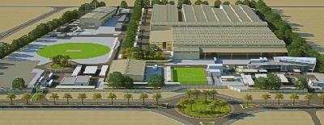

Project: Taweelah Aluminum Extrusion Plant
284 Million AED

Page 1 of 3

Highlights:
Manage all the installation of Telecommunication work including CCTV, Access control system and all data points. Cable pulling of Cat 6 and fiber optic. Cable pulling HV and LV cable. Installation of cable tray cable trunking piping of GI and pvc pipe.Glanding and termination work.

Key Responsibilities for Electrical Foreman
- Coordinate with the site engineer about the priorities of the work.
- Proper tool box talk to the worker before start the work.
- Coordinate to the store man about the materials to be used in site.
- Make sure all tools and equipment are in proper condition.
- Maintain the time management of the work.
- Supervise all the workers, sub-contractor.
- Maintain good quality condition of the work.
- Proper implementation of safety work and policies.
- Proper planning of work techniques so the work will be easy.
- Maintain the working area clean and healthy.
- Teach all workers proper working methods or techniques.
- Prepare daily reports.

BUTEC Co. (Shah, Abu Dhabi UAE) August 2011 – June 2015
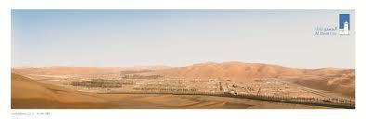

Project: Shah Gas Development project of Refinery/ Oil & Gas

360 Million AED

Highlights:

Managed the work of erection of lighting panel, power panel, HVAC unit, CCTV, Fire and Gas System, and we do all the cable pulling and glanding and termination of small power socket, lighting, control panel in HVAC using PLC display monitor. Commissioning of HVAC, cameras and access control system on 8 Sub Station and 4 Instrumentation Equipment Shelter. Glanding and termination work.

Key Responsibilities as Electrical Foreman
- Coordinate with the site engineer about the priorities of the work.
- Proper tool box talk to the worker before start the work.
- Coordinate to the store man about the materials to be used in site.
- Make sure all tools and equipment are in proper condition.
- Maintain the time management of the work.
- Supervise all the workers, sub-contractor.
- Maintain good quality condition of the work.
- Proper implementation of safety work and policies.
- Proper planning of work techniques so the work will be easy.
- Maintain the working area clean and healthy.
- Teach all workers proper working methods or techniques.
- Prepare daily reports.

Page 2 of 3

ELECTRICALFOREMAN

Project: D5110 Siemens/ Butec Consortium | 2007-2011
Construction of 13 Units of 33/11kV Substations in Eastern Abu Dhabi UAE

Client: Abu Dhabi Water and Electric Authority (ADWEA)

Key Responsibilities as Electrical Foreman
- Coordinate with the site engineer about the priorities of the work.
- Proper tool box talk to the worker before start the work.
- Coordinate to the store man about the materials to be used in site.
- Make sure all tools and equipment are in proper condition.
- Maintain the time management of the work.
- Supervise all the workers, sub-contractor.
- Maintain good quality condition of the work.
- Proper implementation of safety work and policies.
- Proper planning of work techniques so the work will be easy.
- Maintain the working area clean and healthy.
- Teach all workers proper working methods or techniques.
- Prepare daily reports.

April 1999 – 2008 : OLEO MANUFACTURING CORPORATION

Address: Philippines

PRODUCTION OPERATOR/ELECTRICIAN

Duties and responsibilities:

- Check all the parameter of the machine if its work properly.
- Coordinate with the supervisor according to production consumption.
- Log all the material that used in the production.
- Dismantling submersible motor for replacement of bearing or any electrical work.

- Welding and pipe work.

EDUCATION:
National School of Arts and Trade. | June 1993 – March 1997
Bachelor of Science in Industrial Technology.
Master in Electrical.

PERSONAL INFORMATION:
❑ | Date of Birth | : | May 11, 1975 | ❑ | Marital Status | : | Married
❑ | Age | : | 41 | ❑ | Languages | : | English, Tagalog
❑ | Nationality | : | Filipino
❑ | Visa | : | Visit/Tourist Visa

Page 3 of 3

