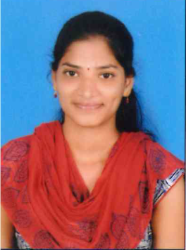

HINDUJA
HINDUJA.346453@2freemail.com

OBJECTIVE:
To become a successful professional in the software field and to associate myself with an organization that provides a platform to update myself as per the need and also contribute to the growth of the organization.

WORK EXPERIENCE:
- Worked as MIS Executive in Good Health Tpa Services for one year
- Worked as Office Administratorin Version Information Technologies PVT LTD.
RESPONCIBILITIES HANDLED:
- Simplifying tasks by making use of Excel options like Vlookup, Countif, Pivot, and SumIFs.
- Arranging the MIS and bulk Analysis reports to Corporates on daily basis.
- Preparing Monthly and Weekly Analysis reports as per company requirements.
- Planning and preparing monthly reports pertaining to finance required for maintaining office infrastructure and facilities.
- Ensuring timely implementation of the project.
- Processes, Documentation, Business Control checks, audits etc.
- Specialization in handling back office operations and inter-office correspondence.
- Assisting the department in project management and implementing business expansion plans.

EDUCATIONAL QUALIFICATION:
- MCA (Computer Applications) from Osmania university Women’s collegeHyderabad during the year 2012-15 with 65%.
- BSC (MPCS) from N.S.V Degree College (Kakathiya University) Jagtial during the year 2009-12 with 64%.
- Intermediate (MPC) from Sri Vani Junior college Jagtial during the year 2006-08 with 72%.
- SSC from Vignan Vidhyalayam Jagtial during the year 2005-06 with 80%.

STRENGTHS:
- Work with positive attitude to contribute the healthy functioning of the organization.
- Self-Confident and Great Patience.
- Willingness to Learn.
- Adaptability to change environment.

TECHNICAL PROFILE:
Office Package : MS-Office with Advance Excel
Languages : C, C++, DS, Java
Operating Systems : Windows Server 2008 and 2003, windows 7, 8, 10, vista XP
Databases : SQL

Academic Project:
Project title : HOSPITAL DEVICE MANAGEMENT
Software Used : JAVA (JSP, SERVLET)
Team Size : 1
Back end : Oracle10g
Operating system : Windows XP.

Description:
The administrative user can create new users and change their passwords. He can add the doctor’s information as well as new doctor’s details. He can check information related to device availability. The administrator can view the management reports. The administrator will be having the privileges to add new employee (Technical/Non-Technical)and also remove the employees. The doctors can change their own passwords. He can order the new devices according to requirement and information of device availability. Finance Department will get the new orders from administrator and they will get the new devices from the market. The finance department will assign the devices to the doctors according to their requests.

Declaration:
I do hereby declare that the above statement given by me is true to the best of my knowledge and belief and I look for a chance to prove my competency.

