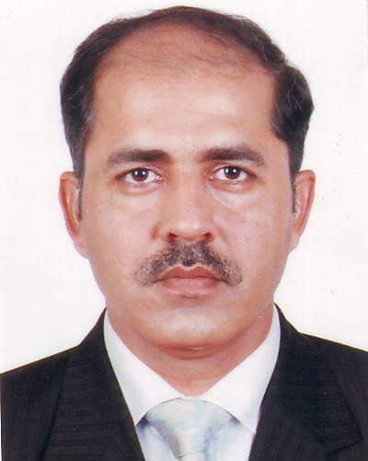
Tahir

Tahir.346515@2freemail.com

OBJECTIVE
A challenging position sought with a progressive organization where professional experience and knowledge can be subjugated. A high level of commitment and professionalism in return for challenging job satisfaction and the opportunities to build experience.

INTERPERSONAL SKILLS
- Strong communication skills resulting in ability to understand and communicate with people
- Analytical approach to work, self-reliance and ability to work independently
- Detail-oriented multi-taker and posses strong organization abilities

MANAGERIAL QUALITIES
- Ability to maintain the relationship with different Govt / Semi – Govt & private organization
- Ability to produce target oriented plans / schemes to achieve certain goals and targets
- Having a very sharp experience of presentation at various levels
- Experience of making contacts and negotiations
- Have experience to work under pressure / critical situations and to travel on regular basis to look after / control the various projects of the organization

ACADAMIC QUALIFICATION

- Diploma in Commerce, D.Com 1991 Government College of Commerce, Rahim Yar Khan
- Certificate in Commerce, C.Com 1990 Government College of Commerce, Rahim yar Khan Pakistan
- Secondary school certificate examination, Matric 1989 Government Pilot Secondary School, Rahim yar Khan Pakistan
- Computer Course, Computer Operating Course 1996 National Computer Services, Lahore Pakistan

WORKING EXPERIENCE

1-Public Relation Officer( 2011 to 2016)
The Documentation Business Man Service L.L.C

1-Plant Operator (March 2008 to September 2009) Sharjaha General Cont, CoSharjaha UAE Operational and maintainace of fully Computerized Concrete Baching plant and Supervise the Mixer truck Driver & Plant helper
2-Supervisor (June 2003 to Feb. 2008) National Database & Registration Authority Government of Pakistan, Rahim Yar Khan Pakistan NSRC Rahim Yar Khan
Supervising efficient functioning of procedures performed by the employees. Managing office work.
To maintain the flow of the people inside and outside the center.
To check the staff in proper dress and create neat and clear environment.
To create job rotation and maintain the duty roster.
To arrange cleanness of center.
Customer Care and public dealing.
To solve the problem of applicant while using CRM, FTRC and checking documents of applicant.
To solve the complaints of customers and provide sufficient solution and to make them satisfied.
Communicate with AM/SE for the latest ftp letters and discuss for better learning.
Cash handling and submission into band.
To high light the issues and problems of the center in front of management.
Proof reading of scans forms to avoid QC rejection.
Form receiving of scans forms to avoid Qc rejection.
Form receiving from MRV's.
3-Sales Consultant (Jan2002 to Dec2002)
EFU Life Insurance Ltd, Rahim Yar Khan Pakistan
Maintained thorough records of sales and database of client information.
Working as a Sales officer
- Setup the Financial services in the market
- Making good and long Relationship with Customer
- Responsibility for the market survey
- Responsibility of the monthly sales target

