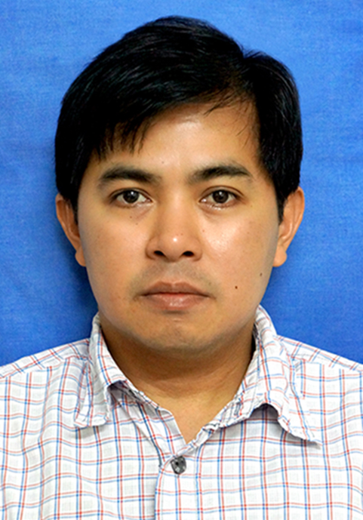
Arnold
Email: Arnold.346541@2freemail.com

PROFESSIONAL EXPERIENCE
Flex Singapore Jun 2015 – Present
Manufacturing Engineer
Responsibilities:
- Test Lead Engineer in-charge for Xerox product build from assembly to final testing. Update and implement ECN.
- Participate in LEAN manufacturing, Kaizen, Gemba.

Heptagon (Advanced Micro Optics) Singapore Jun 2014 – Jun 2015
Test Engineer (Contract)
Responsibilities:
- Buy-off Test Equipment (SPEA-Handler & NI tester-Labview) at supplier site and release for mass production.
- Provide technical support to maintenance team for minimum downtime and higher UPH.

Ntegrator Pte Ltd Singapore Feb 2013 – Feb 2014
Assistant Project Manager (contract)
Responsibilities:
- Main contractor to Singtel for the implementation, operations and maintenance of Fiber Optics.
- Certify Test Report and prepare service claims.

TP Vision (S) Pte Ltd (formerly Philips Electronics) Singapore Nov 2011 – Nov 2012
Philips Electronics (S) Pte Ltd Singapore July 2007 – July 2008
NPI Test Engineer (Contract) ~ Consumer lifestyle, LCD / LED TV
Responsibilities:
- Implement test & measurement methods for prototypes of LCD/LED TV in PCB and set level base on schematic diagram.
- Provide & maintain proper documentation related to the project including test procedures, test plan, test scripts & test reports.
- Design test fixtures/jigs & provide to our supplier for fabrication and do pre-release at their site in Belgium (IPTE).
- Liaise with the supplier & EMS (Engineering Manufacturing Service) for the installation of the testers, supports the test definition process & resolve issues during implementation at the EMS sites.
- Responsible for the equipment (ATE) & test application that is placed under consignment.
- Support pilot run up to ramp-up at the EMS site PCBA factory in Brazil (TPV), Hungary (Elcoteq), Poland (Jabil) and Philips final assembly in Brazil.
- Initiates Gauge R&R, Cp/Cpk analysis values for the release of the testers during pilot run.
- Provide technical support to productions for continuous improvement of FPY (first-pass-yield) & minimum tester downtime, improve cycle time and participate in cost reduction project.
- Evaluate TV’s main SW to resolve false reject or perform failure analysis in Lab environment.
- Implement additional test to improve delivery quality of the product.
- Coordinate with the supplier & EMS for corrective action if there’s any Engineering change.
Accomplishments:
- Successfully launched the project at the EMS in Europe and in Latin America on time with required results.
- Support EMS to handle tester and proper troubleshooting procedure resulting in reduced tester downtime & better yield.

Applied Materials Inc. Singapore July 2010 – Nov 2011
Associate Engineer
Responsibilities:
- Works from complex test procedures, electro/mechanical schematics and PLC, diagrams & layouts to perform testing, checkout & troubleshooting functions.
- Performs operational test & fault isolation on CVD (chemical vapor deposition) tool. That used in Wafer Fabrication.
- Working in a lab environment performing activities including PM preparation, uptime monitoring, system safety checks, engineering parts installation and facility setup.
- Perform Robot calibration and reliability testing of the product.

Singapore Télécommunications (FTTH) Singapore Feb 2009 – Jul 2010
Associate Engineer (Contract)
Responsibilities:
- Implementation, operations and maintenance of Next Generation National Broadband Network (NGNBN) project in Singapore.
- Provide GPON assignment & necessary materials to contractor for the installation of fiber optics for OSP (Outside Plant) & FTTO/FTTH (Fiber-To-The-Office/Home).
- Follow-up & complete work order for our customer on time.
- Liaise with the planner for project amendment for any site issues.
- Test Lead for verification of work done by contractors using OTDR & Power Meter.
- Provide technical support to our Field Technicians and contractors during break down.
- Prepare service order & process claims to contractors using SAP system.
- Supervised the team of Engineering Officer.
Accomplishments:
Part of the team that accomplished to finished the phase 3 projects above expectation.

Avago Technologies (formerly Agilent Technologies) Singapore Nov 2000 – May 2007
Senior Associate Engineer (Fiber Optics Product Division – Test Engineering)
Responsibilities:
- Production support in troubleshooting & repair of ATE in testing Fiber Optics Transceiver product and resolve issues in the line with minimum downtime.
- Set-up multiple test system for volume ramp in production using various Test instruments e.g. Digital Data & Spectrum Analyzers, Wide-BW Oscilloscope, Light wave Transmitter, LMM, DMM, Optical Attenuator, Optical Switches, Pulse & Pattern Generator, Omni Bert, Colby Delay, VXI system, SMU, Pico Ammeter, Error Detector.
- Special support to SW Developer for R&D projects to optimize, upgrade & develop test system.
- Maintenance and calibration for test instrument, fabricate test fixture, repairs of DUT board & spare parts management.
- Debugged test program to optimize the test flows & stability during production under HP Vee, HP Basic and UNIX test executive.
Accomplishments:
- Effectively recycled test system spare parts during period of company cost cutting to ensure continued line support within budget and critical timeframe & participated in cost reduction.

Acer Information Products Philippines Nov 1998 – Mar 2000
In-Circuit Testing (ICT) and Automatic Test Equipment (ATE) Engineer (Notebook division)
Responsibilities:
- Responsible for monitoring, debugging and troubleshooting of ICT/ATE machine and the fixture in testing laptop motherboard such as Teradyne, Genrad & TRI in-circuit test machines.
- Modify test program to enhance test coverage and reduce cycle time.
- Support Engineering counterpart in Taiwan during Pilot run.
Accomplishments:
- Lead the vendor to quickly set-up efficient Automatic Test Equipment & buy-off in the midst of mass production to achieved the target outputs.

ACADEMIC QUALIFICATION and PROFESSIONAL DEVELOPMENT

Bachelor of Science in Electronics and Communications Engineering 1997
Mapua Institute of Technology, Manila Philippines

ADDITIONAL EXPERIENCES AND INTEREST
- Windows NT/XP, Mac OS & Unix environment
- MS Word, MS Excel, MS PowerPoint & other Windows office tools
- Philips Faststand Test Platform (run in CVI engine) and applications are made by text base script
- HP Basic, Agilent VEE (HP), Jett Tools, VXI, PXI test systems, Labview
- Familiar in various IEEE standards such as I2C, RS232, DVI, USB, LAN, JTAG, GPIB com and CAN protocol
- Experienced in In-Circuit Testing, final module testing & boundary scan test
- Soldering, schematic diagram, PLC, GPON, RF Technology, Fiber Optics
- Basketball, Football, Volleyball, Tennis, Movies, Music, Travel

