COVERING LETTER

Dear sir / madam:

It is with great interest that I am forwarding my CV / resume for your consideration.
My record of academic achievements and professional career history, demonstrates attributes that make me a valuable employee.

My CV/ resume are enclosed to provide you with details of my skill and accomplishments but I am certain that personal interview would more fully reveal my desire and ability to contribute to your organization.

Thank you for your time and consideration and I look forward to speak with you soon.

Yours sincerely,

ASIF

ASIF.346550@2freemail.com

ASIF 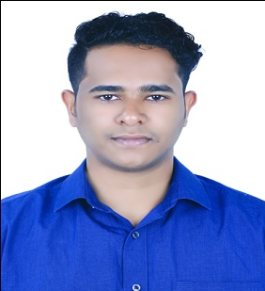

Synopsis

- Young, energetic and result oriented M.com with B.Com professional with 1 year’s professional experience in accounts field.
- Fluent in all accounts affairs could be handled professionally and independently.
- Computer proficient in accounts software tally, MS excel, word, access, power point, internet application, and possess high speed typing skill.
- A skilled communicator both oral and verbal with exceptional presentation skills and abilities in taking initiative and possess high level of confidentially.
Educational Credentials

- M.com from bharathiar university, India in 2016. (Final result waiting).
- B.Com from kannur university, India in 2014.

Work Experiences

MICRO CORPUS

( manufacturers & sellers) kasargod, Kerala, India.

(Dec’ 14 – Nov’15)

Designation: Assistant Accountant.

Profile
- Knowledge up to finalization of accounts.
- Day book preparation and vouching.
- Verification of bank reconciliation and confirm with bank statement.
- Managing petty cash transactions.
- Prepared payroll, wages.
- Handling cheques.
- Monitoring customer account details for non- payments, delayed payments and other irregularities.
- Responsible for Recording, Posting and Maintenance of Purchases, Sales, Journal, Payments & Receipts, Inventory, General Ledger Contra Entries and Cash Book using Tally 9.
- CPAT
Tax and service centre (account& practice) Cannanore, Kerala, India.
(May’ 13 – October’ 13)
Designation: trainee as a part of my graduation.
Profile
- Knowledge up to E-filing-return, taxes, Vat and also worked as tax practitioner.
- Handled general accounting system.
- Attending phone calls & replying to query emails.
- Working knowledge in Tally accounting software.
- Basic understanding of accountancy.
- Depreciation calculation.
- Prepared purchase day& return book, sales day& return book.
Certification Courses

- Successfully completed course in Diploma in Computerized Financial Accounting.
- Successfully completed the requirements to be recognized as a Microsoft office specialist for Office Excel® 2007.

projects

B.com 6th semester
Subject: Overall performance of the organization.

Personal Details

- Date of Birth 8th Jul 1993
- Marital Status Single
- Languages known English& Malayalam
- Basic(read write) Arabic& Hindi, Tamil

References

Available upon request.

