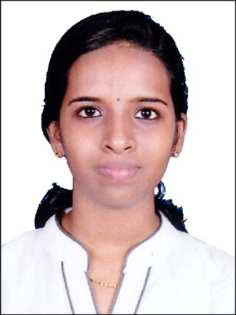  Libina  Libina.346630@2freemail.com  Hobbies  Traveling  Reading  Listening music | CURRICULUM VITAE  OBJECTIVE  Intend to build a career with leading corporate of speedy environment  with committed and dedicated people, which will help me to explore myself fully and realize my potential, willing to work as a key player in challenge.  WORKING EXPERIENCE  A4M GROUP OF COMPANIES  DUBAI  FROM OCT – 2015 – NOW  Working as Receptionist and Administrator.  Duties And Responsibilities  - Managed receptionist area, including greeting visitors.  - Handled phone calls and customers enquire.  - Handled employee’s attendance record log on the daily basis.  - Track stocks of office supplies and place orders when necessary.  - Recorded and entered all customers’ details in spreadsheets.  - Prepared sales report.  - Takes and delivers messages or transfers calls to voicemail when appropriate personnel are unavailable.  - Answer phones multiple phone lines, route calls to appropriate department or individuals.  - Telemarketing and Email Marketing.  - Digital Social media marketing.  - Prepared quotations and invoices, and coordinated with customers.  - Handling Petty cash and Maintaining Report.  CANARA BANK  VETTILAPPARA – KERALA  FROM OCT – 2014 TO MAR -2015  Worked As Assi. Accountant  Duties and responsibilities  - Prepare accounts-Pass entries in Tally/Other ERP Software.  - Keep record of petty cash transactions, tracking bank related  Activities.  - Keep Record of Statutory Related Matters and bank reconciliation.  - Online account creation.  EDUCATION BACKGROUND  Course Board/University Year of passing Specialization Grade  TALLY ERP.9 G-TECH 2014 A GRADE  BCA Mangalore university 2013-2014 Computer languages 70%  +2 Kerala 2010-2011 Science 65%  10th Kerala 2008-2009 ………. 75  COMPUTER KNOWLEDGE  - Good working experience in Microsoft Office Packages.  - Experience in Microsoft Windows Operating Systems (Win 98/XP/Vista/7/).  - Good skill in internet applications.  LANGUAGE SKILLS  - English  - Hindi  - Malayalam  - Kannada  - Tamil  DECLARATION:  I hereby declare that the above mentioned facts are true to the best of my understanding and belief.

