RESUME 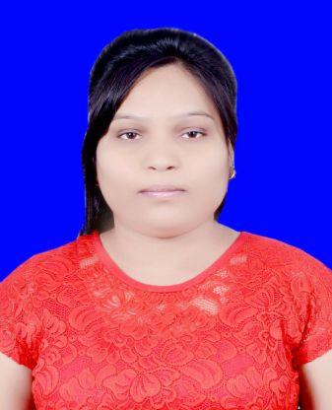

SHWETA
SHWETA.346665@2freemail.com
CAREER OBJECTIVE
To work in a challenging and dynamic environment and keep adding value to organization that represent and serve to myself while concurrently upgrading my skills and knowledge.
Professional Skills
- Excellent knowledge of chemicals.
- Good command over use of chemicals.
- Practical knowledge of chemical testing.
- Can take quick action as required.
- Maintain safe and clean environment.
- Quick responding.
- Computer savvy.
- Aware about the safety rules while using chemicals.
Academic Qualifications
- M.Sc. INORGANIC CHEMISTRY with 76.88% from Allahabad University, Allahabad, Uttar Pradesh, India in 2015.
- B.Sc.-B.ZC with 54% from Allahabad University, Allahabad, Uttar Pradesh, India in 2013.
- Intermediate Board of Intermediate Education with 54% from Jagat Taran Girls Inter college, Allahabad, Uttar Pradesh, India in 2009.
- S.S.C Secondary School Certificate with 61.33 % from Jagat Taran Intermediat College, Allahabad, Uttar Pradesh, India in 2007.

Academic Projects

- In M. Sc.- Neuclear Magnetic Resonance
- IN B.Sc.- Analysis of the Chemical Compounds
Computer Skill: Good Knowledge in MS Office and internet
Strengths:
- Hard working, disciplined, self motivated.
- Positive attitude to learn new technologies.
- Quick adaptation to a situation.
- Ability to work independently and in team environment.
Extracurricular Activities
- Member of NGO of our college which work for education of poor girls.
- University toppers in post graduation.

Declaration :
I here by declare that above information is given by me is true and correct to the best of my knowledge.

