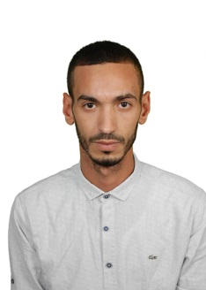
Name : Mohyiddine
Contact no : C/o 0505891826
Email : mohyiddine.346731@2freemail.com
Visit visa
Career objectif

I would like to work for a company that will enhance the skills I already have as well as provide the opportunity for personal and professional growth and advancement opportunities.

Work experiences experiences :
- 07/2013 to 03/2014 : sales executive at’BOURJOIS’, Oran /algeria
- Goals set for centres month on month, maintaining relationship with target customers, customer service, ensuring high rate of return on investmen.
- Responsible for assigned sales targets.
- Develop new sample for client.
- Responding to incoming email and phone enquiries.
- Attending team meetings and sharing best practice with colleagues.
- 05/2014 to 01/2015 sales assistant at ‘celio’ in Algeria responsible for :
- Innovative and able to develop new ideas for improving sales.
- Assisting customers in the selection and purchase of items.
- Ensuring that the shop counter is always manned.
- Responsible dealing with customer complaints.
- 02/2015 to 08/2015 :’ assistant manager’ at SETIF MALL:
- Assisting the manage in organizing, planning and implementing strategy.
- Coordinating operations.
- Ensuring schedules and objectives are met.
- 09/2015 to 01/2016 : working as ‘translator’ at CEVITAL company in Algeria :
- Presenting at meetings with the boss.
- Doing outdoor representations and sellings.
- Translating ‘-french- english’
- 02/2016 to 08/2016 : ‘assistant manager and translator’ at ISIS in Algeria :
- Dealing with workers and control them.
- Build a good relashion betwen the boss and the workers.
- Prepare meetings and translating.
- several experience working as ‘translator’ at fairs (/ English / French/Arabic) as a part time job.
Education:
- June 2013: Baccalaureate degree.
- 2015: bachelor degree (license).in English lge

.
Personal skills and Key strengths :
- A highly motivated person Punctual, reliable and willing to learn.
- Leadership,sense of organization, good experience in project and team management.
- Self-motivated and hard-working, good communication skills.
- Strong planning skills, fast learner who thrives in a rapidly changing environment.
- Fully PC literate, including spreadsheets, e-mail, internet and word processing.
- Licensed to drive B category vehicles.
Languages:
Arabic: Mother tongue.
French: fluent ; formation language
English: fluent.
- Additional skills: Microsoft office.
- Interests: Reading, sports, travelling, photography
Personal details
- Date of birth : 27. 12.1993
- Nationality : algerian
- Marital status : single

