Curriculum vitae

Objective

To acquire a challenging position where I can put optimum use of my knowledge, skill & creativity; where I can initiate ideas among team members & thereby work together as a family, towards the growth and development of the organization.
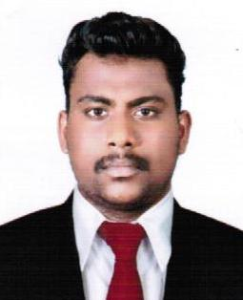

SOJO
SOLO.346767@2freemail.com

PERSONAL INFORMATION

D.O.B : 8-9-1991
Gender : male
Religion :Christian, anglo-
indian
Nationality : Indian
Marital status : Single

Educational Qualification
- BBA ,M.G University
- PLUS TWO, Board of Secondary Education , Govt. of Kerala
- SSLC , Board of Public Examination, Govt. of Kerala

Previous Experience
Abaam hotel ( A unit of chinar homes pvt.ltd ) as a Accountants assistant 1.5 year in There Finance Dept. (Tally erp , Hotsoft)

Job Profile
- Maintaining general ledgers and sub ledgers.
- Preparation of payment vouchers, Cash and cheque.
- Preparation of Bank Reconciliation statement.
- Office Administration and Correspondence.
- Experience in day to day cash & bank transaction.
- Accounts receivables & Payables
- Make week wise collection plan
- Prepare sales report on monthly basis
- Luxury Tax. Service Tax , VAT.
.

Previous Experience

Worked in a Firm (Accounts Service Society) as Accountants assistant 1 year in There Accounts & Audit Division Tally ERP, SAP B 1

Job Profile
- Enter all transaction into tally package
- Receive and Verify invoices for goods and services
- Prepare and process accounts payable cheques and transfer letters.
- Prepare manual cheques as and when required..

- Reconciliation of accounts payable & Receivables.

- Monitor accounts to ensure payments are up to date.
- Verify the documents and prepare Sales Invoices to Clients
- E-filing
- KVAT

Worked as accountants assistant ( 3 months )Tax matters , Regd sales tax consultancy , Thrissur

Job Profile

- Assisting accounting work & vouching
- Experience in sales tax return filling & Make Internet payments througs NEFT/RTGS.
- Preparation of bank reconciliation.
- Maintaining manual cash book and computerized cash book.
- Preparation of cheque issue registers.
- KVAT
- E-filing

Computer skills
- SAP Business One
- Peachtree
- Tally ERP9.0
- Hot soft
- MS Word , Excel
- Quikbooks
.
Interests
- Listening to Music.
- Playing Cricket
- Travelling.

Success
- I will try to utilize all the opportunities I get which can lead to the goal called Success.

Declaration

I hereby declare that the information furnished above is true to the best of my knowledge.

