IMRAN
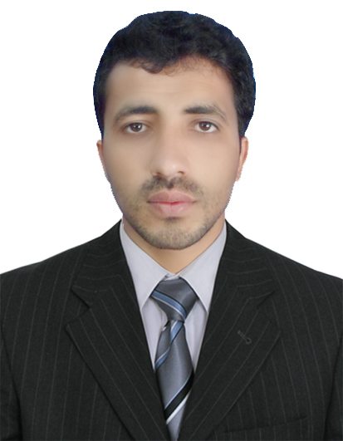

Cell: C/o 0502360357

Email: imran.346779@2freemail.com

Job Objective

To use my skills and potential to assist an organization in achieving its goals which seeking long term career with optimum growth. This objective would be supported by my qualification.

Personal Information

      - Date of birth 16th March 1992
      - Religion Islam
      - Nationality Pakistani
      - Domicile Hangu
      - Marital Status Single

Education

Degree/Certificate | Obtained /Total Marks | % Marks obtained | Year | Board / University
S.S.C  (Science) | 679/900 | 75 % | 2008 | B.I.S.E Kohat
F.SC  (Pre Engineering) | 657/1100 | 61 % | 2010 | B.I.S.E Peshawar
BSCS (Honors) | 3.31CGPA /4.00 CGPA | 75 % | 2015 | KPK Agricultural University Peshawar Pakistan

Computer Skills

- Win 98/XP 2000-2010 Professional
- MS Office (MS. Word, MS. Excel, MS. Power point)
- Internet exploring.
- MCSE
- CCNA Certified
- CCNP Routing
- CCNP Switching
- CCNP Troubleshooting
- CCTV

Professional Experiences

- Six months internship in PTCL
- Group project on Layer 2 , Layer 3 and System security , Designed Network for North West Hospital.
- One year Teaching Experience at Islamia Public School and College.
- One year Working Experience at Corvit Cernter Peshawar as a IT administrator.
- I have passed Cisco Certified Network Associate Exam with great result.
- Cisco Certified Network Professional exam in progress.

Languages

- English
- Urdu
- Pashto

=

Personal Characteristics

- Optimistic thinking
- Self motivated & able to take initiative
- Studious and confident.

Reference

Will be furnished on demand.
:

