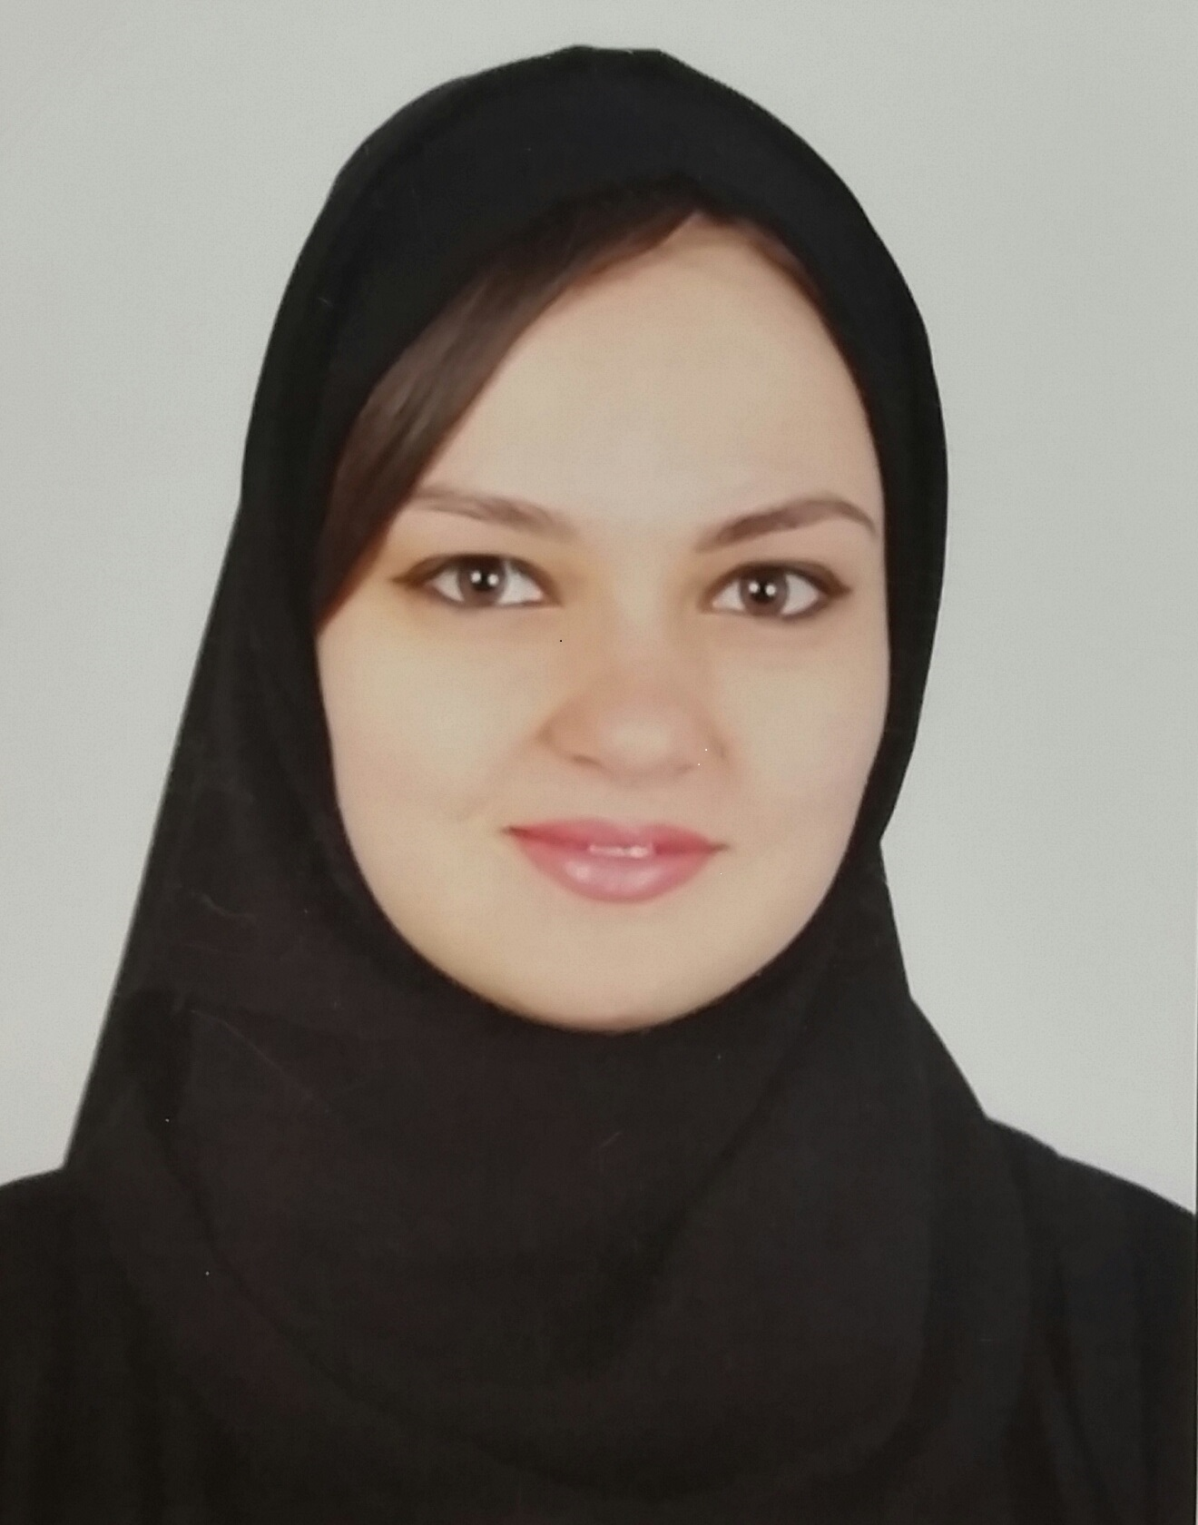 Name : LAKATOSH
Personal Details

Nationality: Ukrainian

Date of birth: 17.12.1989

Sex: Female

Address: Sharjah , UAE

Civil status: Not married

E-mail address: LAKATOSH.346899@2freemail.com

Career Objective
To Find Myself In a Professional Company That Provides Consistent Development
Future Growth.
Work experience:
Pharmacy Clerk-Sales Person, Mediclinic Dubai Mall, UAE 10.2014-04.2015
- Direct communication with patients and clients;

-Taking prescriptions for customers;

-Relaying information between pharmacists and customers;

-Selling and promoting cosmetic products, vitamins, machines and etc.;

-Work as a cashier;

-Monthly inventories, arranging the display, making orders, receiving orders, reported

to management;

- Working with colleagues to achieve the target.
Sales Associate 03.2013-09.2014
Azadea –Promod Shop-United Arab Emirates
Responsibilities :
- greets customers and serves efficiently and courteously on shop in order to ensure the provision of the highest standard of customers service at all points in the shopping experience .
- maintain knowledge of current sales and promotions , policies regarding payment and exchanges and security practices in order to ensure store policies are adhered to at all times.
- handling cash , knowledge and respect of store procedures

Receptionist 10.2012- 02.2013
“Movenpick” hotel – United Arab Emirates
Responsibilities:
-negotiating with the client
-answering telephone calls promptly and politely
-keep all the record and important files in order
-servicing the customer politely
-assist the customer kindly and patiently
-give the proper information to the customer
-maintain the cleanliness of the environment
-organize the place station working
-responsible for customer satisfaction
Administrator 09.2011-12.2011
fitness studio “Fit-fly”–Ukraine
Responsibilities:

-negotiating with the client
-answering telephone calls promptly and politely
-keep all the record and important files in order
-servicing the customer politely
-assist the customer kindly and patiently
-give the proper information to the customer
-maintain the cleanliness of the environment
-organize the place station working
-handling cash
-responsible for customer satisfaction

Universal Teller 10.2007 – 07.2011
“Home Credit Bank”- Ukraine
Responsibilities:
- Cashier activities
- Processing in time customers operations
- Withdrawal , payments , currency exchange
- Selling and cross selling debit cards, current accounts, deposits
Education:
- Dnepropetrovsk State Finance Academy (Ukraine) –period - 2011-2012
Banking
Master degree
- Dnepropetrovsk State Finance Academy (Ukraine) –period - 2007-2011
Finance and Credit
Bachelor degree

- High School –period - 1997-2007

High School certificate
Foreign languages :

- Ukrainian :mother tongue
- Russian: mother tongue
- English: good
Personal skills and competences:

- Driving license
- Dynamics, flexible
- Capacity of adaptability to other cultures
- Coordination skills
- Teamwork skills

Internal Training :

- Excellent customer service “Azadea” 09.04.2013
- Cross and up selling “Azadea” 14.05.2013
- Handling customer complaints “Azadea” 11.02.2014
- Heartsaver CPR AED “Mediclinic Dubai mall” 17.03.2015

