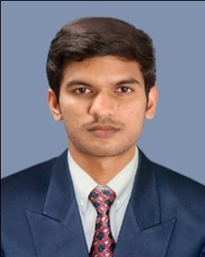  SONAL  Email: sonal.346989@2freemail.com  Personal Data:  Date of Birth :04-12-1991  Gender : Male  Religion : Hindu  Nationality : Indian  Marital Status : Single  Languages known : English, Hindi, Malayalam. | Career Objective  To take up a profession which helps me to strive ahead and  climb the ladder of success, completely exploiting my acquired skills and abilities and providing an atmosphere to  learn more. Also to acquire a Challenging career in my  interested field where I can apply my knowledge & help the  Organization growth.  Course completed  Certified in professional Autocad, Electrical cad.  Technical Skills  Software: c, c ++, Auto cad, Electrical cad, MS-Office, MS-excel.  Field of Interest  Designing and Analysis, Maintenance, and Production.  Strength  - Hard working  - Sincerity  - Quick learning  - Helping nature  Experience  Two year experience in solar power plant as a site engineer.  Project Profile  Main Project: Level –Shifting Multiple- Input Switched-Capacitor Voltage Copier.  Responsibilities Done  -250 KW projects successfully completed under my responsibility.  -On-Grid (without battery) and Off-Grid (with battery) power plants are successfully completed in different sites.
RESUME
B-Tech(Electrical and Electronics)

Education Qualification

- Bachelor of Technology (B.Tech.Electrical and Electronics)
FromMangalam College of Engineering, Ettumanoor under
Mahatma Gandhi University (MG) [2009-2013]

- 12th
FromG.B.H.S. school Vaikom (STATE)(2009)

- 10th
From K.P.M.H.S school Poothotta(STATE)(2007)

Hobbies
- Interested in playingfoot ball,Badminton etc
- Interested in driving Car and Motor Cycle./.
- Interested in listening music.

Declaration

I hereby declare that the above mentioned information is correct up to my knowledge and I bear the responsibility for the correctness of the above mentioned particulars.

