Rahath
Rahath.347084@2freemail.com

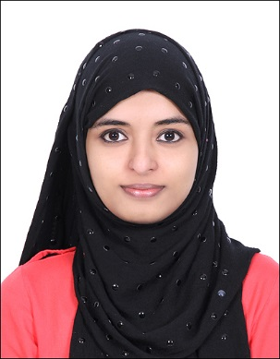

PROFESSIONAL OBJECTIVE

To secure a position where I can efficiently contribute my skills and abilities for the growth of the organization and build my professional career.

ACADEMIC INFORMATION

B-Tech Main project : Canteen Automation.
Canteen automation use microprocessor based intelligence to integrate or control or deliver product and system in the canteen.
Mini Project : DC motor speed control using PIC
Seminar : Wireless charging of Mobile phones
Diploma Main Project : Railway signaling system.

EDUCATIONAL BACKGROUND
B.Tech in Electronics& Communication Engineering at KRGCEW, Kerala University
Course completion: June, 2016
Diploma in Electronics and communication at Carmel polytechnic, State board of Technical education
T.H.S.L.C from Govt. Technical High School with an aggregate of 82%

Strengths: Flexible, Active Participant, Good Communication verbal and written, Proactive, Influencing, Team building.

Salary Expected: As per Company Standards

DECLARATION

I hereby declare that all the information furnished above is true to the best of my knowledge and records.

