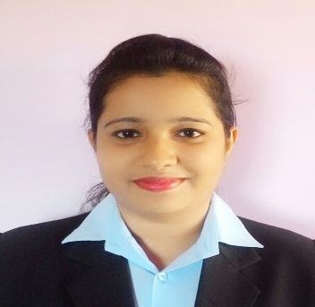

Name: PRAVITA
PRAVITA.347102@2freemail.com

CAREER OBJECTIVES
To serve in a growth oriented organization for a challenging position offering growth potential and responsibilities. Self-motivated and hardworking for reliable professional progress and career advancement through tremendous determination and dedication.
EDUCATIONAL QUALIFICATION
COURSE / DEGREE | SCHOOL/ COLLEGE | UNIVERSITY/BOARD | YEAR OF PASSING
S.S.L.C | Holy Family High School | Karnataka Board | 2009
P.U.C | St. Agnes PU college | Mangalore University | 2011
B.SC | St. Agnes Degree College | Mangalore University | 2014

PROFESSIONAL QUALIFICATION
Masters of Hospital administration (MHA), Rajiv Gandhi University of Health Science. (2016)
Computer Proficiency
Post Graduate Diploma in Computer Application (PGDCA)
PROJECT PROFILE
Dissertation:
Study on the Importance of Human Resource Accounting in Alva’s Health Centre Moodbidri. The study was conducted using explanatory research design and a structured questionnaire techniques is used for the collection of data from the management and other staffs. The research design used for this study is Descriptive type.
Achievement
Been an active member of N.S.S and participated in various activities for the betterment of the society.
Academic Skills
- Organization Behavior
- Principles of Management
- Statistics and Research Methodology including research ethics
- Accountancy in Health Care
- Epidemiology, Public Health Administration in India & Medical Ethics
- Materials Management
- Financial Management in Health Care
- Health Economics
- Human Resource Management
- Marketing Management
- Legal issues in Health Care
- Hospital Planning and Designing.
- Management of Hospital Service
- Quality Management in Healthcare
Credentials
- “Prospects and Challenges in Basic Sciences”- Regional Level 2012
- “Two days science fair, materials for the future”- Regional Level 2013
- “Emerging trends in biological science”- National Level 2013
- “Costing of Hospital services”- Regional Level 2015
- “A Concave on Go Green in Health Care”- Regional Level 2016
- “CME planning of Hospitals” - Regional Level 2016
- “Frugal Innovation in Health Care”- National Level 2016

Strengths
- Leadership Quality
- Hard Working
- Trust worthy
- Confident

Interest:
Reading articles related to management, giving power point presentation and participating in group discussion.
I assure you that the above furnished information is true to the best of my knowledge and belief.

