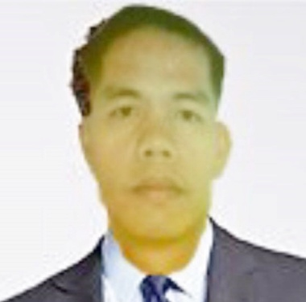
MARCIANO
MARCIANO.347112@2freemail.com

Career Objective: To secure a post that suits my qualification and shoulder the responsibilities of the job competently to give best possible results to the employer
_________________________________________________________________________
Knowledge and Skills: Microsoft Word, Microsoft Excel, Bookkeeping, Quickbooks, Capable of working under time pressure, Fast learner.
_________________________________________________________________________

Employment History:

- Company : Capuyan Sunflower
Address : La Trinidad Benguet, Philippines
Position : Accounts Payable/Recevable
Inclusive date: Feb. 01, 2012 – March 30, 2015

- Company : La Trinidad Multi-Purpose Cooperative
Address : La Trinidad Benguet, Philippines
Position : Bookkeeper
Inclusive date: May 2006 – June 2010

- Company : Local Government Unit
Address : Nueva Era, Ilocos Norte, Philippines
Position : Office Assistant (Inventory Clerk/Record Clerk)
Inclusive date : September 2004 - March 31, 2006

- Company : Nangalisan Enterprise and Construction Supply
Address : Laoag City Ilocos Norte, Philippines
Position : Sales Associate
Inclusive Date : May 1999 – July 2004

Trainings and Seminars Attended:

February 23, 2007 “Bookkeeping & other Taxes Compliance Seminar”

December 17, 2008 “SPAS/PFRS Seminars (Int’l Acctg. Standard)

April 16, 17 & 23, 2006 “Strategic Dev’t Planning Workshop”

Educational Background:

Tertiary :

: Missions Education Certificate
: La Union, Philippines, 2014

: Bachelor of Theology
: International Christian College
: Baguio City, 1998

: Bachelor of Arts
: Northern Christian College
: Laoag City, Phils., 1996

Secondary : Sinait National High School
Sinait Ilocos Sur, Philippines, 1992

Primary : Cabugao Elementary School
Cabugao, Ilocos Sur, Philippines, 1988

Personal Information:

Date of Birth : March 8,1975
Civil Status : Married
Gender : Male
Religion : Pentecostal Christian
Citizenship : Filipino

I affirm that all of the above information is true and correct to the best of my knowledge.

