EVA

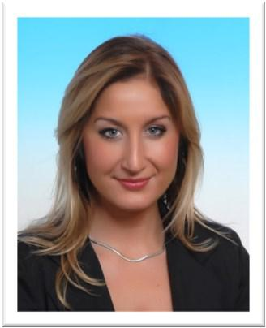

PROFILE

A skilled senior professional with 10+ years of diversified experiences in the hospitality industry. 5 languages spoken in advance level, including English and German. Highly motivated and committed to establish myself as a professional in the Hospitality, tourism, leisure & entertainment Field. Proactive person, able to work in a multitasking environment with competing deadlines and used to international contests.

Hospitality &
Tourism manager

Eve.347201@2freemail.com
Nationality: Czech

Qualification

School of hospitality and tourism Professional Diploma Czech Rep 1999- 2003

PROFESSIONAL EXPERIENCE

Hotel U Matasů. (N. Room: 50. Central location in city) Plzeň, Czech Republic

Hotel Manager 2011- present

- Supervises general operations to guarantee the fulfillment of the established service, quality, image, functionality, maintenance and security standards

  - Execution of marketing campaigns for the hotel and F&B outlets to increase brand awareness and generate revenue, ensuring maximum ROI for each activity.

  - ROI analysis of each operation to provide periodic reports to the hotel’s stakeholders.
  - Organization of special events, media launch and on site photo-shoots.
  - Creation of a social media strategy, track and analysis of results and effectiveness.

  - Implementation of digital campaigns targeting new markets across different channels.
  - Development and growth of the hotel’s databases to promote all hotel activities.
  - Collaboration with multicultural team to ensure implementation of marketing activities

La Colombe Travel, Achrafieh Beirut, Lebanon

Travel Guide, Manager 2008-2010
Company: branch of Czech Group CK Fatima. Hospitality, Tourism, leisure, entartainment

- Organization and management of onsite activities

- customer relathionship management ensuring that the tour is fulfilling the plan

- dealing with emergencies
- liaising with hotels, coach companies, restaurants and other clients
- organising and attending tourism events, conferences, workshops and exhibitions

- writing reports and maintaining records

Hotel and Restaurants Plzeň, Czech Republic

Hotel Restaurant supervisor, assistant manager 2005- 2008

- Managing accounts of Clients. Coordination of Training Programs, Administrative tasks.

KEY SKILLS

- 5 Languages: English (fluent), Czech (mother tongue), German, Slovak, Croatian (fluent)
- IT Skills: Microsoft Office programs (Word, Excel, Power Point)

- Good team player well organized and constantly committed to develop my skills and knowledge.

- Having a flexible attitude and positive approach
- Able to tactfully deal with difficult and sensitive situation

INTEREST

Sports (swimming, skiing), fashion (design my own clothing), cooking, traveling

Additional Note: BIG 5 Exhibition experience held in Dubai (UAE) in 2016. Fila Chemcals Group (Middle East, Asia branch)

