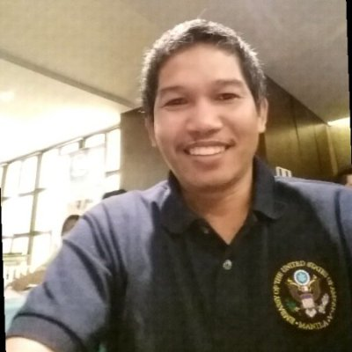
RAMIL
RAMIL.347245@2freemail.com

Personal Profile:
Started my career path as a multi tasking accounting staff in the corporate enterprise such the like of general trading, logistics, trucking and container dock services and accounting firm industries.

Humanitarian interest has been an integral part of my life and in my profession. My years of experience in organizational development, project management, logistics, finance and administration, and with several years of experience in the development and private works will be useful to the overall program goals of an organization.

Career Highlights:
General Accounting
Daily recording of company / organization expenditures, maintain and update supplier and consultant ledgers, customer accounts, update journals and handled Accounts Payable and Accounts Receivable Ledger, petty cash disbursement, invoice processing, check disbursement and preparation, report generations to various government agencies (taxes, insurance etc..) budgeting and cash forecasting, payroll processing, encoding to accounting software and various bank transactions.
Procurement
Negotiated various purchase orders and contracts to vendor to get best value of money for the company / organization, coordinate and collaborate to internal and external parties for cost effective deliveries and minimized over stocking and warehousing cost and established credit line to various vendors, suggest opportunities to management to avoid / minimized delays and costs.
Logistics and Distributions
Developed and planned the entire procurement process from vendors selection to contracting, established contacts from processing of customs clearance and to the distributions, developed and execute logistical plans of distributions and provided support for the emergency project.
Warehouse Management and Inventory
Maintained and update stocks and managed documentations of releases and receipts, identified appropriate storage facilities and required support staff, managed warehouse operations, and supervised the work of personnel, invoice preparation, delivery receipts for various deliveries, maintained monthly physical inventory count and prepares reconciliation reports of any variances against book balance.
General Office Administration
Provided administrative support to the director of administration in ensuring the smooth administrative operation of the office by disposing tasks related to efficient office upkeep, procurement of goods and services, coordination with service providers and vendors, inventory and safekeeping of office supplies, and provision of logistical support to company's activities.
Overseeing the overall safety and security of the project office and personnel, coordinated related matters with government agencies and NGO’s, such as the Armed Forces of the Philippines (AFP), Philippine National Police (PNP), the United Nations (UN), other implementer / contractors of USAID Projects.
Provided constant administrative advice and guidance to program staff and closely coordinated with the program personnel on matters related to administrative, financial and personnel policies and procedures and compliance.
Provided administrative support to training and other project activities, such as preparation and packing of training materials, attending to participants’ registrations, etc.

Career History:
1. United States Agency for International Development (USAID)
July 2013-December 2016 – Administrative and Logistics Officer – Education Project
February 2012-June 2013 – Administrative and Finance Officer – Education Project
June 2009-January 2012 – Administrative Assistant cum Procurement – Education Project
April 2007-November 2008 – Junior Account – Governance Project
October 2004-September 2006 – Administrative Assistant cum Inventory Custodian– Health Project

2. Prestige Brands Phils., Inc. (Distributor of branded FMCG)
November 2000-August 2003 – Accounts Assistant

3. Maxinter Corporation (Importer of industrial materials, container dock, trucking services)
August 1998-October 2000 – Accounts Assistant

Special Projects in various companies ( Audit Assistant, Inventory Development, Business set up, Book Keeping and Taxation)

Education:
Graduated 1998, Bachelor of Science in Accountancy at University of the East (UE), Manila, Philippines

Skills and Knowledge Information:
Management Skills: Administration,Organizational Development, Project start up, operations and close out, Security and Safety Management, Finance Management, Financial and Administrative Requirement of donor funded projects, Company formation or Business set up.

Logistics Skills: Procurement, Import, Fleet Management and Maintenance, Cargo Handling International and Domestic (Sea Air and Land), Warehouse , Distributions and inventory Management, Travel and Hotel Bookings International and Domestics, Venue and vendor contracting , and Materials and Manpower Outsourcing.

Computer skills: Windows application, MS Word , Excel and Power point, Outlook, Fox Pro Integrated Accounting Software, Alpha Financial Information System (AFIS), Fox Base Data Base and Quick Books.

Seminars and Training:
Cost Effective Purchasing & Efficient Procurement Management, November 24-25, 2015
Inventory Control and Management, April 7, 2016
Various Training on Security and Safety, Earthquake and Fire

