MIRSHAD
MIRSHAD.347249@2freemail.com
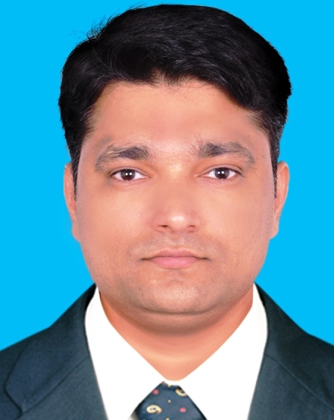
Overview:

- B Com and MBA Finance Graduate from University of Calicut, Kerala, India.
- 11+ years of Experience in Operations & Management- Accounts Payable/Invoice processing, Reconciliation, Underwriting, Mortgage Loan Servicing and Asset Management and Training & Development.
- Experience in Cost minimization and Process Improvements, gather information and prepare requirements sheet for the new technical changes for the improvement of the process and to ensure the strict Compliance.
- Experience in coordinating with the Technical team for the implementation of the new system changes, perform UAT testing and validation.
- Experience in process transition; Travelled to Pennsylvania State and Florida State in the USA for Process Transition. Currently, holding USA B1 Visa valid till the Year 2023.
- Specialized in Client/Vendor Management, offering fresh insight and a passion for innovation; track record in planning & Management, Quality Control and ensuring Compliance.
- Detail oriented, self-starter with the ability to lead as well as participate effectively in a team environment. Excellent facilitator and trainer, skilled at training and helping team work together for efficiency and productivity.

Career Objective:

Seeking a challenging position in a reputed organization, where I can use my core competencies for the growth of the organization and thereby grow with the Organization. Core competencies include-

- Communication Skills | - Management and Leadership Skills
- Analytical and Research Skills | - Client Management Skills
- Finance Skills | - Inter-Personal Skills
- Process Management Skills | - Planning and Organizing Skills
- Project Management Skills | - Strategic Thinking Skills
- Process re-engineering skills | - Problem-Solving Skills
- Gap Analysis and UAT Testing | - Excellent Team Player and Trainer
- Process transition Skills | - Strategic Planning and Coordination
- Accounts Payable process Skills | - Expert in Microsoft Office Packages

Professional Experience:

Professional Experience Details-Snapshot
Organization | Designation | Location | Duration
AMT World Trade Pvt Ltd. | Operation Manager | Kerala, India | February 2015 to Present
Ocwen Financial Solutions Pvt Ltd. | Assistant Manager | Bangalore, India | May 2005 to December 2014
Bismi Medicals (Part Time) | Accountant-Part time | Kerala, India | July 2000 to April 2005

  - Designation: Operation Manager.
Organization: AMT World Trade Pvt Ltd.
Duration: February 2015 to Present

AMT World Trade Pvt Ltd. is a leading distributor of Samsung phones in Kerala. As an Operation Manager, I supervise, coordinate, manage and monitor the workings of sales and service departments in the organization.

Key Responsibilities:

- Coordinate, manage and monitor the workings of various departments in the organization.
- Review financial statements and data. Utilize financial data to improve profitability. Prepare and control operational budgets. Control inventory. Plan effective strategies for the financial well-being of the organization.
- Improve processes and policies in support of organizational goals. Formulate and implement departmental and organizational policies and procedures to maximize profitability. Monitor adherence to rules, regulations and procedures.
- Plan the use of human resources. Organize recruitment and placement of required staff. Establish organizational structures. Delegate tasks and accountabilities. Establish work schedules. Supervise staff. Monitor and evaluate performance.
- Coordinate and monitor the work of various departments involved in warehousing, pricing and distribution of goods. Monitor performance and implement improvements. Ensure quality of products. Manage quality and quantity of employee productivity.
- Manage customer support. Plan and support sales and marketing activities.
- Provide senior management with timely reports, documenting observations during the process and/or vendor/client reviews and identify trends or opportunities for improvement with recommendations.

  - Designation: Assistant Manager-Default Servicing Dept.
Organization: Ocwen Financial Solutions Pvt Ltd., Bangalore-India
Duration in Ocwen: May 2005 to December 2014

Ocwen Financial is a provider of residential and commercial mortgage loan servicing, special servicing and asset management services. Ocwen is headquartered in Dunwoody, Georgia, with additional offices in Philippines, Uruguay and India. In August 2009, Ocwen completed the distribution of its Ocwen Solutions line of business via the spin-off of a separate publicly traded company, Altisource Business solutions Private Ltd.

As Assistant Manager, I supervised a group of 4 Team Leaders and their Team to meet the required daily objectives and managed the Team portfolios to ensure all assets are being managed effectively.

Key Responsibilities:

- Ensure strict compliance of all internal Policies & Procedures and Operational Controls.
- Identify and research internal process gaps, works with departmental leaders and Technical Team to solve issues, performing the UAT Testing and close gaps with timely resolution.
- Identify and research external audit and compliance discrepancies and initiates viable actions for a timely resolution.
- Feedback to employees and Training & Development.
- Managing the Clients/Vendors diplomatically.
- Analyze and discuss the problem scenarios within the team in an effort to offer alternative solutions prior to elevation of the issue.
- Ensure Timelines are met for all processes and present formal findings to Management as needed.
- Provide senior management with timely reports, documenting observations during the process and/or vendor/client reviews and identify trends or opportunities for improvement with recommendations.
- Familiarize the team with the Goals and Objectives and design standards, techniques and tools to achieve the same.

Earlier Assignments:

Team Leader : Ocwen Financial Solutions Pvt Ltd., Bangalore-India.
Quality Analyst : Ocwen Financial Solutions Pvt Ltd., Bangalore-India.
Associate : Ocwen Financial Solutions Pvt Ltd., Bangalore-India.
Accountant Part-time : Bismi Medicals, Kondotty-India

Key Achievements:

- Instrumental in giving an elevated performance while building morale and motivation among the team members.
- Created an environment oriented to open communications, creative thinking, cohesive team efforts and collective decision making.
- Successfully completed the Gap Analysis for Accounts Payable/Invoicing Process and implemented a new process where the Company could save a substantial amount of Fees and Costs.
- Implemented a new process in place to collects refunds from Vendors and could collect lots of refunds which improved the fund balance of the Company.
- Proactively undertook the ownership and convinced the management in changing the process operation style and thereby improved the quality and compliance.
- Received appreciation from Senior Management for drastically reducing the trailing expense (Loss rate).
- Kept the morale of the team very high which helped me in getting the assigned tasks completed within the timeline and also delivering low attrition percentage.

Technical Skills:

- Knowledge of Windows Operating System and Microsoft Office Packages.

Education:

MBA-Finance-2004 (Regular Course)
University of Calicut, Kerala.
Passed with First Class.

Bachelor of Commerce (B-Com) – 2001
University of Calicut, Kerala.
Passed with First Class.

10th Standard (CBSE) 1996
Markazul Uloom English School, Kondotty, Kerala.
Passed with First Class.

Personal Information:

Date of Birth : 27-MAY-1980
Nationality : Indian
Marital Status : Married
Languages Known: English, Hindi, Tamil and Malayalam
Reference : Will be provided upon request.

