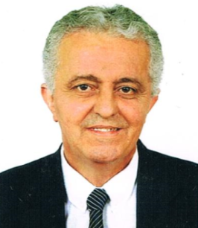
CURRICULUM VITAE

Youcef Gender: Male
Marital Status: married
Nationality: Algeria
Youcef.347289@2freemail.com

Objective
Doctor specialist, with thirty five years experience in internal medicine and twenty six years in the field of diabetes, seeking a position in public or private healthcare.
(Holding UAE-MOH evaluation certificate)
Career History:
1979-2016: Consultant in internal Medicine - University Hospital of Constantine
1979-2016: Teacher at the Faculty of Medicine - University Hospital of Constantine
1986-2016: Consultant in diabetology - University Hospital of Constantine
1986-2016: Head of Diabetology unit - University Hospital of Constantine
1988-2016: Medical expert for the social insurance funds
1975-1978: Technical assistant in physiology - University Hospital of Constantine

2002-2016: Researcher at the diabetology unit: Faculty of Medicine of Constantine
Academic Record
2006: Professor of internal medicine - University Hospital of Constantine
2001: Associate professor of internal medicine - University Hospital of Constantine
2000: Doctor Es Medical Sciences of internal medicine
1991: Training studies in diabetology
CHU Louis PASTEUR -Strasbourg- France

1984-85: Training studies in diabetology and artificial pancreas
CHU de L’Antiquaille – Lyon – France
1983: Diploma of Specialist in Internal Medicine
Assistant Professor in Internal Medicine
1979: Diploma of MD degree
1972: Bachelor Degree (Baccalaureat Science)

Additional training and award:
2003: Gold Medal and Averroes First Price
MGSD congress (Mediterranean Group for the Study of Diabetes) Lisbon 2003

1997: Training study in E.S.P. (English for specific purpose)
Aston Triangle University - Birmingham (U.K.)

Professional Affiliations
- Member of SAMI : «Algerian Society of Internal Medicine »
- Member of SAD: « Algerian Society of Diabetology »
- Member of SAC: « Algerian Society of cardiology»

Languages

French: spoken and written
English: spoken and written
Arabic: spoken and written

Skills
Word, Excel, PowerPoint

Extra Curricular Activities

Music (piano)
Outside Interests: Swimming,

