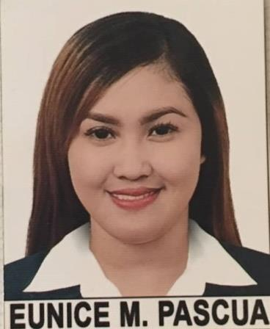

EUNICE

Eunice.347295@2freemail.com

OBJECTIVE

- To be able to land in a good job where I can be comfortable in showing my knowledge and skills while improving my personality
- Open to new ideas
- To have experience
- Willing to work under pressure

PERSONAL PROFILE

Nickname | : | Niki
Date of Birth | : | January 14, 1993
Place of Birth | : | Manila
Gender | : | Female
Height | : | 5’2 ft
Weight | : | 48 kg
Civil Status | : | Single
Citizenship | : | Filipino
Religion | : | Roman Catholic
Father’s Name | : | Rolando C. Pascua
Occupation | : | Laborer
Mother’s Name | : | Sarah M. Pascua
Occupation | : | Housewife

EDUCATIONAL BACKGROUND

Tertiary:

School: Access Computer & Technical Colleges
Address: C.M Recto Avenue corner Quezon Blvd., Manila
Course: Bachelor of Science in Computer Science

Year: 2012-2016

Secondary:

School: Florentino Torres High School
Address: Juan Luna St. Gagalangin Tondo Manila
Year: 2005-2009

Elementary:

School: Lakan Dula Elementary School
Address: Solis St. Tondo Manila
Year: 1999-2005

SKILLS

- Well versed with MS office especially MS Word, Power Point Presentations and shortcuts of MS Excel.
- Exceptionally well organized, efficient and disciplined.

- Excel at multi-tasking and time management.

WORK EXPERIENCE

- 2 years freelancer as a virtual assistant

CHARACTER REFERENCES

I hereby certify that the above information is true and correct to the best of my knowledge and belief.
Applicant

