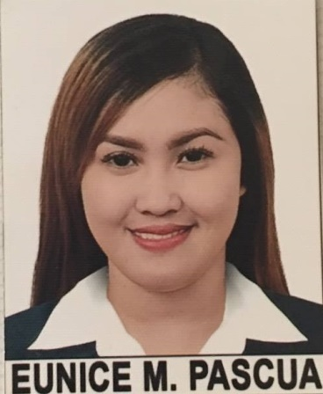

EUNICE
Eunice.347298@2freemail.com

OBJECTIVE

° To be able to land in a good job where I can be comfortable in
showing my knowledge and skills while improving my personality
° Open to new ideas
° To have experience
° Willing to work under pressure

PERSONAL PROFILE

Nickname : Niki
Date of Birth :
Place of Birth : Manila
Gender : Female
Height : 5’2 ft
Weight : 48 kg
Civil Status : Single
Citizenship : Filipino
Religion : Roman Catholic
Father’s Name : Rolando C. Pascua
Occupation : Laborer
Mother’s Name : Sarah M. Pascua
Occupation : Housewife

EDUCATIONAL BACKGROUND

Tertiary:
School: Access Computer & Technical Colleges
Address: C.M Recto Avenue corner Quezon Blvd., Manila
Course: Bachelor of Science in Computer Science
Year: 2012-2016

Secondary:
School: Florentino Torres High School
Address: Juan Luna St. Gagalangin Tondo Manila
Year: 2005-2009

Elementary:
School: Lakan Dula Elementary School
Address: Solis St. Tondo Manila
Year: 1999-2005

SKILLS

• Well versed with MS office especially MS Word, Power Point Presentations and shortcuts of MS Excel.
• Exceptionally well organized, efficient and disciplined.
• Excel at multi-tasking and time management.

WORK EXPERIENCE

• 2 years freelancer as a virtual assistant

I hereby certify that the above information is true and correct to the best of my knowledge and belief.

Applicant

