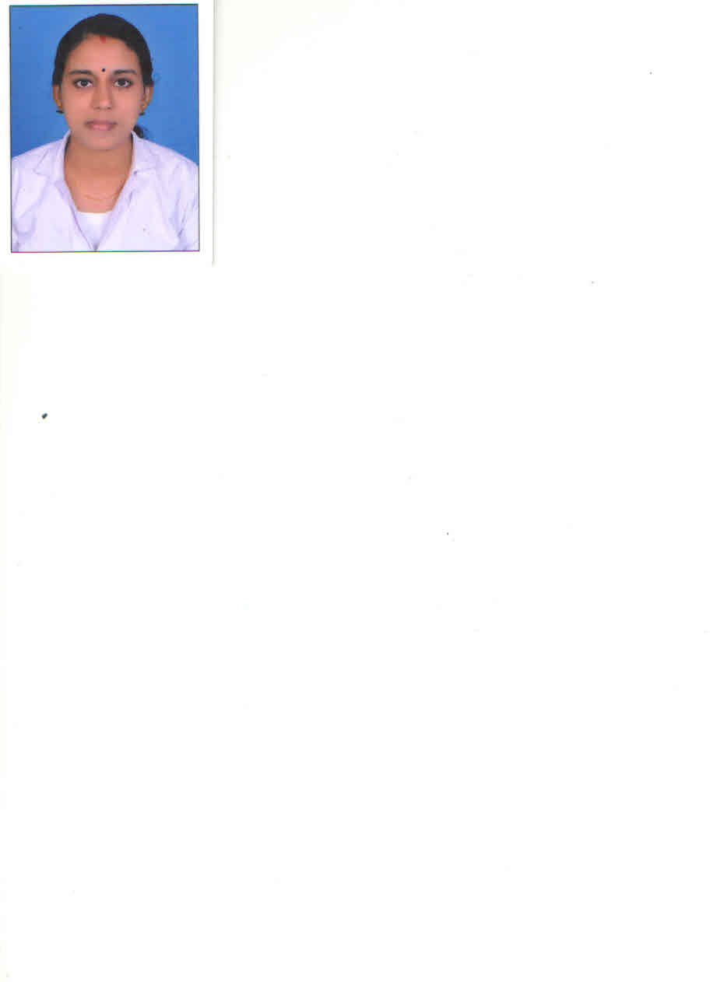
Renjini
Renjini.347342@2freemail.com

OBJECTIVE
To achieve a challenging position in your organization and to work in a team efficiently to spend my life in serving the sick with utmost dedication and service utilizing all the skills and expertise acquired over the years of nursing care
PROFESSIONAL QUALIFICATION
5year as a Staff Nurse (Emergency and Medical, Surgical Ward)
EDUCATIONAL QUALIFICATION
- Post Basic Bsc Nursing from Dhanwantari Collage of Nursing, Bangalore, Rajiv Gandhi University Karnataka ,India.
- General Nursing from M.A.J School of Nursing, Banglore,Karnataka Diploma in Nursing Examination Board.
- Bsc Zoology from Devasom Board Collage , Santhamcotah, Kerala , Kerala University ,India.
COMPUTER KNOWLEDGE
Familiar with the fundamental of computer, Ms Office and Internet
MEMBERSHIP AND REGISTRATION
- DHA- Registered Nurse
- Registered PcBsc Nurse in Kerala State Nursing Council
- GNM,Nurse in Kerala State Nursing Council ,
- GNM, Nurse in Karnataka State Nursing Council,
- Basic Life Support , BLS ( American Heart Association )
- Advanced Cardiovascular Life Support ( ACLS)- American Heart Association

CAREER DETAILS
Previous Experience:
Name of the Employer : Aravind Medical Center, Chavara,Kollam, Kerala, India,
Period of Working : 02-03-2009 to 30-08-2011
Designation and Dept : Staff Nurse in Emergency and Medical, Surgical Ward

Recent Experience:
Name of the Employer : Aravind Medical Center, Chavara,Kollam, Kerala, India,
Period of Working : 01-01-2013 to 10.08.2015
Designation and Dept : Senior Staff Nurse in Emergency and Medical, Surgical Ward

Job profile in Aravind Medical Center:
Emergency Room:-
- Receiving the patient with his emergency situation and help the patient to get necessary care
- We must provide initial treatment for a board spectrum of illness and injuries.
- Immediate care given when he was any life threatening situation like cardiac arrest as per in BLS and ACLS manner.
- Immediate care given to the patient like Asthma, Respiratory situation distress
- Sudden Nursing care to the patient like Head Injury ,RTA
- Follow universal precaution and infection control protocol
- Special attention for the spiritual, physical, Personnel needs.
- Taking EGC and caring of Machine and tools
- Maintained and checking inventory
- Assisting the dctor’s instructions
Medical, Surgical Ward:-
- Basic Nursing procedure like Admission, Transfer and discharge
- Orientation on the job staff training
- Clinical Management of Medical and Surgical Ward
- Patient care regarding medical condition, treatment and long term maintenance rationalize by Scientific Knowledge
- Follow universal precaution and infection control protocols
- Special attention for Spiritual, physical, Personal needs
- Interact with departments regarding patient care
- Resuscitation procedure and inflection Control
- Computerized maintenance of patients charts and confidential life
- Assisting the doctors for all type of bed procedure
PERSONAL PROFILE
- Gender : Female
- Date of Birth : 31/05/1984
- Marital Status : Married
- Nationality : Indian
- Religion : Hindu
- Languages Known : English, Hindi, Tamil, Kannada and Malayalam,
- Visa Status : Husband’s Sponsorship

DECLARATION
I, Renjini by submit these curriculum vitae for your kind consideration and for favorable orders. I assure you sir, if I am selected, I will discharge my duties to the entire satisfaction of my superiors. I declare that the information furnished above is true to the best of my knowledge.

