Susan
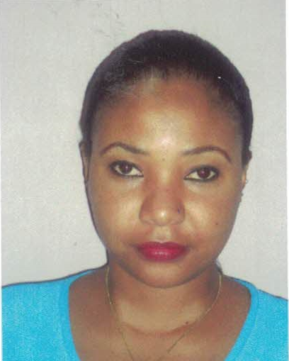
Susan.347376@2freemail.com

_____________________________________________________________________________________________
Objective: To obtain a challenging position with a stable and professional company that utilizes my experience in marketing strategies coordination, product management, and business development.

SKILLS PROFILE
I am a Marketing professional with skills on carrying out insights from, content marketing, advertising, brand positioning and branding, consumer behavior, comparing it with internal sales data. Strategic thinker and innovator who can lead successful teams, research and implement sales, marketing and business analysis to support future growth and expansion. I particularly have strong relationship management skills with a track record of driving revenue and profitability gains within highly competitive markets. I am now seeking a position with an organization where demonstrated skills in leadership, content marketing, branding and advertising can be used to increase profitability and promote growth.

EMPLOYMENT HISTORY

INN DUBAI 2016-2017
Marketing Coordinator Contract (1year contract)
Duties and Responsibilities:

- Organizing the production of branded items such as stationery and merchandise
- Supporting the in-house marketing and design team by coordinating and collating content
- Producing additional marketing communications, such as flyers, brochures and exhibition-related projects
- Setting up tracking systems for marketing campaigns and online activities.
- Track competitor activity by keeping abreast of market changes and the marketing mix used by competitors
- Assisting with the production of artwork, sourcing images, print buying and checking copy.
- Produce clear and concise written correspondence in the form of letters and emails.
- Assisting team members with day to day marketing tasks and coordinating marketing projects and activities as requested.

TANAGOLD GRAIN MILLERS LIMITED 2014-2015
Telemarketing Agent
Duties and Responsibilities:

- Contact businesses and private individuals by telephone to promote products, services and/or charitable causes.
- Solicit orders for goods and services over the telephone.
- Explain the product or service to potential customers.
- Deliver scripted sales pitch to the customer.
- Adjust scripted sales pitch to meet needs of specific individuals.
- Provide pricing details.
- Handle customer questions.
- Obtain customer information including names and addresses.
- Record customer details including reaction to the product or service offered.
- Receive orders over the telephone.
- Input order details into the computer system.
- Record customer details and details of transaction.
- Confirm orders placed with field sales representatives.
- Obtain contact details of potential customers from sources including telephone directories and purchased lists.
- Schedule appointments for sales staff to meet prospective customers.
- Conduct customer and marketing surveys.
- Answer telephone calls from potential customers who are responding to advertisements.
- Contact customers to follow up on initial interaction.

RESOLUTION INSUARANCE 2013-2014
BUSINESS ASSOCIATE SALES
Duties and Responsibilities:
•Developed and maintained business relationships with customers and prospective customers to generate new business for the organization’s products and services.
•Provided services to clients’ changing insurance needs by selling Property, Accidents, Motor, Personal Accident and Health insurance.
•Completed coverage by delivering policy; planning future follow-up visits and evaluation of needs.
•Advised clients on market conditions and insurance related matters.
•Expedited the resolution of customer problems and complaints reports directly to the Business development officer.
•Approached potential clients.
•Responded to all customer needs and concerns.

EDUCATION BACKGROUND
- BA, International Business and Marketing Edith Cowan University July 2014
- Diploma in Business Studies -1 & 2 Australian Studies Institute 2012-2013
- Certificate IV- University foundation studies Perth Inst, Business & Tech 2010-2011
- Kenya Certificate of Secondary Education Nyahururu Elite Senior School 2006-2009
- Telemarketing technics 12 hours workshop A. parliament of training experts Feb 2017

Awards and certifications:
- Certificate of Participation in The Baden Powell Memorial Project, I participated in the fundraising walk in Nyeri as a Scout member,2001
- Certificate of Merit from Help Age Kenya, For special efforts in raising funds for the welfare of the aged in need,2002
- Certificate of Merit from Busara Forest View Academy, For citizen of the year,2005

****References available upon request*****

