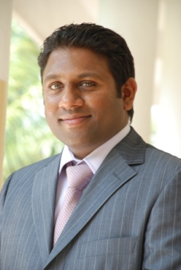
Safarudheen.347419@2freemail.com

Safarudheen

Experience (years): 10 +

Objective

Highly versatile and seasoned professional with excellent skills in Account management, sales, marketing and business development in UAE. During his tenure; he had held positions as Sales Executive, Business Development Executive, Account manager and Marketing executive. His expertise includes exceptional knowledge in IT hardware and software products, commodities trading, electronics and IT business. He has excellent skills in marketing and business development, company establishment and distribution/wholesale channel development.

He hold diploma in Electronics Engineering, IT, Sales and marketing training and certificates. He is looking to pursue challenging full time position in Account management/sales. He has UAE resident Visa and driving license.

Key strengths –

- A very good listener and communicator.
- A good follower of office work ethics and culture.
- Ability to work under pressure and provides supporting mentality in all work requirements.
- Profound ability to communicate effectively both orally and by writing.
- A fast learner and enthusiastic approach in professional and career growth.
- A polite, thoughtful and friendly attitude.

Education / Qualifications

I am holding Diploma in Electronics Engineering from SSM Polytechnic, Kerala Board of Technical Education. India.
I am also pursuing Bachelors in Commence from Indira Gandhi National Open University (IGNOU) - http://www.ignou.ac.in/

Experience

- Employer : EMIRATES COMPUTERS Co ltd as Sales/Account manager – 7 Years
- Employer: JUMBO Electronics Co Ltd – Dubai UAE – Sales and marketing – 3 Years
- IBM India – 1 year

Personal Details

Nationality : Indian.
Visa Status : Valid Employment Visa of United Arab Emirates. Transferable
Marital Status : Married.
Present Address : Abu Dhabi. UAE.

________________________________________________

