FEBA
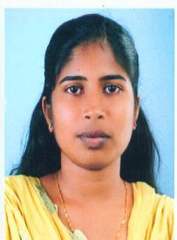
FEBA.347597@2freemail.com

Objective

Seeking a good position in an organizationas an Accountant where extensive experience will be further developed and utilized.

Summary

Working experience in VAT& GST
Hands on experience in ensuring accurate general ledger posting and responding to vendor queries
Working knowledge of Microsoft Office applications
Reorganized accounting procedures by transiting a manual system into a computerized environment
Performed advanced bookkeeping and administrative duties
Communication of messages, receiving phone calls, transferring calls, using judgment calls regarding nature of business and urgency of situation.

Education

2014 M.Com M. G University, Kottayam Kerala, India
2011 B. Com M. G University, Kottayam Kerala, India
2008 Plus two Board Of HSE, Kerala,India
2006 SSLC Board of public Examinations Kerala, India

Other Skills

Company Secretaries Foundation
M.S Office
Tally
Working Experience

2014 June – 2016 December (2.5 Year)Accountant at Coolwin Engineering , Cochin

Works Handled
- Communication of messages, receiving phone calls, transferring calls, using judgment calls regarding nature of business and urgency of situation.
- Data entry duties depending on the task set.
- Preparation of Outstanding reports and presenting to the Management in time
- Reconciliation of customer accounts and passing related entries
- VAT Calculation
- Cash and Bank receipts and depositing of same with bank
- Verification of Receipts
- Sorting out billing / debtors related queries
- Bank Reconciliation
- Handling Petty Cash
- Correspondences with bank
- Handling Reception

Personal Details

Date & Place of Birth: 14th September 1990, Palambra
Sex : Female
Nationality : Indian
Marital Status : Married
Languages Known : Malayalam, English , Hindi

