Poonam.347606@2freemail.com
Poonam
An Accountancy & Finance Professional
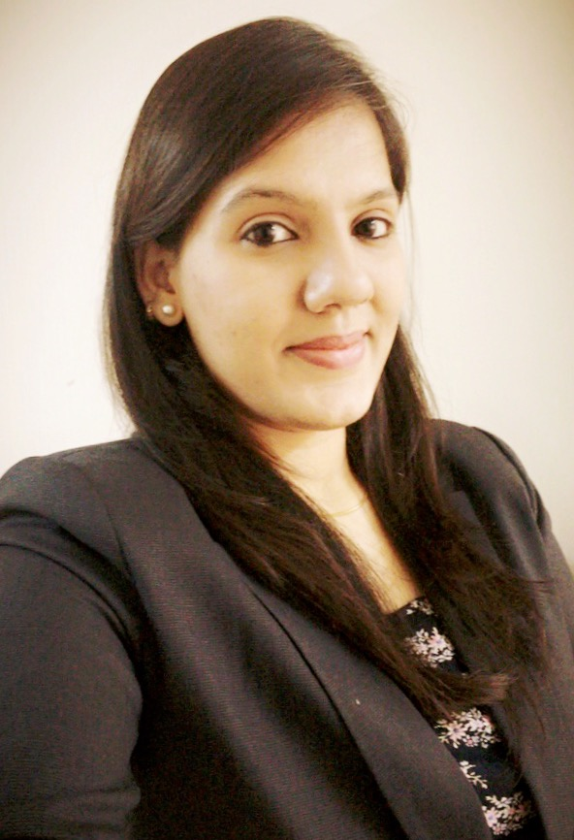

_____________________________________________________PROFESSIONAL EXPERIENCE______________________________________________________
Reliance Petrochem Industries Pvt, Ltd Karachi, Pakistan
Worked as “Accounts Trainee”, April 2015 – Present
Responsibilities/Key Contributions:

- Managing Computerized Accounting Systems
- Monthly Bank Reconciliation Statements of all bank accounts maintained; resolve any differences in a timely manner
- Dealing with banks for Import and B2B LC requirements.
- Providing reports to the management on a monthly basis.
- Consultation on significant matters with various professionals such as lawyers, tax advisors, actuaries and IT experts
- Preparation of all accounting works on daily basis
- Assist the management in tax calculations and filing the tax returns
- Prepare Analysis of Accounts on the request of Higher Management
- Assist with preparation and co-ordination of audit process
- Ensuring compliance with applicable requirements of national legislations, International Financial
Reporting Standards IFRS, international Standards on Auditing ISA’s, company policies and procedures

______________________________________________PROFESSIONAL QUALIFICATIONS_________________________________________________
- Association of Chartered Certified Accountants, UK, (2011 –2016 In progress)
ACCA (Finalist)
- Shah Abdul Latif University, Khairpur (2012-2014)
B.com
- Gul Model Science College Jacobabad, Sindh (2007-2009)
Intermediate

CORE STRENGTHS AND ENABLING SKILLS
- Auditing  - Exports Documentation  - Accounting management  - Financial Management | - Analysis of Financial Statements  - Business Analysis  - Accounts Reconciliation  - Financial Reporting | - Finsoft Accounting Software  - MS Office Suite  - Afroz Accounting Software  - Time Management Skills

Why Poonam
- A goal-driven and prudent ACCA finalist with significant academic knowledge and experience of auditing accounting management, financial management, cash flow management & modeling and accounts reconciliation
- A proficient accountant who aligns financial initiatives to achieve strategic objectives/goals. Detail-oriented professional with excellent understanding of IFRS/IAS, ISA, accounting concepts & framework
- A quick learner who thrives in advanced teamwork situations, highly capable to effectively collaborate with diversely talented teams, an extremely motivated and adaptable person eager to learn industry knowledge and enhance skills for professional development
- A highly skilled individual proficient in financial analysis, prepare concise & accurate financial reports, income statements.
Flat# C24,Block C, khekhasan Apartment,Teen Talwar, Clifton, Karachi, Pakistan

