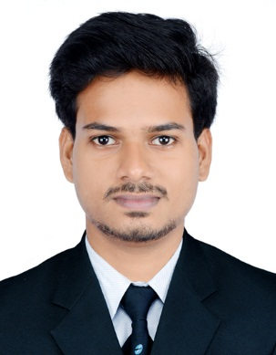
CURRICULUM VITAE

HARISH

HARISH.347677@2freemail.com

OBJECTIVES:
An electrical engineer with electrical designing (MEP) for residential and commercial projects, seeking a challenging role in electrical design and site engineer in MEP with a reputed organization to contribute accrued expertise in formulating organizational profit objectives.

EDUCATIONAL DETAILS
- BE in Electrical & Electronics Engineering from KIT(Visvesvaraya Technological University), Manglore-Karnataka during the period of 2009-2014
- Higher Secondary Education 2007- 2009 Govt. Higher Secondary School,Edappal, kerala..
- Secondary School Leaving Certificate 2007 Govt. Higher Secondary School, Edappal, Kerala.

TECHNICAL QUALIFICATION
Obtained training in Diploma in ELECTRICAL ENGINEERING design (MEP) wih AUTO CAD from Esta Engineering staff training academy ,Calicut,kerala

ACADEMIC PROJECTS
AUTOMATIC RAILWAY GATE OPENING
Description; The main aim of this project is to operate and control the unmanned railway gate in the proper manner in the order to avoid manned railway gate opening.

EXPERIENCE-1
Company- Esta engineering consultancy ,Calicut, kerala
Designation –Electrical design engineer(MEP)
Period- From June 2014 to 30th september 2016

JOB DESCRIPTION

- Responsible for leading the electrical designing related to apartments and villas
- Electrical load estimation,development of single line diagram with protection(Transformer,generator,motor and UPS etc.)
- Cable sizing,bus bar,earthing system according to the load analysis and routing designing.
- Building security systems,CCTV,free alarm system,telecommunication,data services.
- Involved in preparation of lighting desig using Di-Lux software and producing lighting distribution based on Lux level schem.
- Preparation of Bil of quantities for electrical equipments in excel format.
SOFTWARE SKILS
- AUTOCAD,Di-Lux and MS office.

STRENGTH.
- Hardworking, patience.
- Energetic, Confident.
- Truthful and God-fearing.
- Self-motivated.

PERSONAL DETAILS
- Date of Birth : 16-03-1992
- Sex : Male
- Marital Status : Single
- Nationality : Indian
- Languages known : English, Malayalam, Hindi,(Read,write and speak)

DECLARATION
I hereby declare that the information given herewith is correct to my knowledge and I will responsible for any discrepancy

