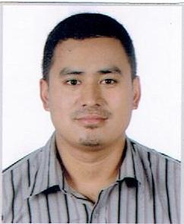
Sagar
Sagar.347689@2freemail.com

PERSONAL DETAILS
Date of Birth: 12th February, 1991
Nationality: Nepali
Marital Status: Single
Religion: Hindu
Visa Status: Visit Visa
EDUCATION
1997-2007: Prerana Boarding High School(Secondary Education)
2007-2009: Martyrs Memorial College(Higher Secondary Education)
2009-2012: Nepal Commerce College
(Bachelor in Business Studies)

RELEVANT EXPERIENCE
2011 to 2012 : Worked in Western Union Money Transfer as a cashier
2013 to 2015 : Worked as a customer service representative in Everest Bank
2015 to 2016 : Working as a Loan Manager in Compass Saving & Co. Org. Ltd
SKILLS
Computer literacy; Microsoft Word,Excel and PowerPoint
Good communication skills and good command in English communication
Good education background in related field
Positive attitude and positive reinforcement

I hereby certify that above information are true and correct to the best of my belief.

