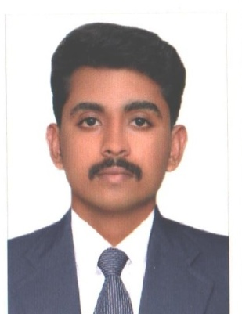

ARUN
ARUN.347732@2freemail.com

PERSONAL DATA:
Date of Birth : 27.04.1992
Sex : Male
Nationality : Indian
Marital Status : Married
Visa Status : Visit Visa
18 Feb 2017 – 19 May 2017
Religion, cast: Hindhu,Thiyya
License : Valid Indian Driving License
CURRICULUM VITAE

CAREER OBJECTIVE
I wish to work in a challenging environment continuous learning where I could show my cent percent hard work and dedication.

ACADEMIC PROFILE
Post Graduation: Master of Business Administration (MBA) .
University : Bharathiyar, Coimbatore.
Specialization : Human Resource and Finance.
College : Maharaja Arts & Science College, Coimbatore.
Qualification | University | Year of Passing | % of marks
MBA (Master of Business Administration) | Bharathiyar University | 2014 | 73 %
BBA ( Bachelor of Busness Administration) | Kannur university | 2012 | 50 %
Higher Secondary Education Certificate | Board of HSE Kerala Government. | 2009 | 67 %
Secondary School Certificate | Board of Public Examination– Kerala | 2007 | 63 %

CORE COMPETENCIES:
Daily Accounting, Cashier , Payroll, Data entry and passing entries, Bank re-conciliation, Return filing, Labour welfare, Cost control, Communication
PERIPHERAL COMPETENCIES
Cultural understanding, Motivation and dynamic, Team work.

LANGUAGES KNOWN
➢ English.
➢ Hindi.
➢ Malayalam.
➢ Tamil.
➢ Kannada
COMPUTER SKILL
➢Tally ERP9, MS- Office (Excel, Word, Power Point).
WORK EXPERIENCE
➢Worked as Accountant at Comb Industries Inc ,Bangalore Karnataka from 20-11-2015 to 30-11-2016.
➢Worked as Accountant at Dcarnival Foods and beverages Pvt Ltd at kochi, Kerala from 1-09-2014 to 11-11-2015.
➢Worked as Accountant at Park Residency at kochi,Kerala from 1-05-2014 to 30-08-2014.
A CADEMIC PROJECT DETAILS
➢A STUDY ON COMPENSATION OF EMPLOYEES WITH SPECIEL REFERENCE TO ANUGRAHA COFFEE CURING WORKS KUSALNAGAR,KARNATAKA.
AREA OF INTEREST:
➢Finance and Human Resource management
SEMINARS AND WORKSHOP:
➢Attend a seminar on medical textile at south India textile Research association, Coimbatore.
EXTRACURRICULAR ACTIVITIES:
➢Winner of College Level Volleyball Tournament in 2013 from Maharaja Arts& Science College Coimbatore.
DECLARATION
I hereby declare that the above furnished information is true and correct to the best of my knowledge and belief.

